;dfh ljsf; ky hgsk'/ / Ps;gP8 g]kfnsf]
;em]bf/Ldf ;+rflnt ;fd'bflos ;zlQms/0f sfo{qmdsf]
b; jif]{ k|ult k|ltj]bg
e"ldsf M

PS;gP8 g]kfn - cGt/fli6«o u}/ ;/sf/L ;+:yf _ / ;dfh ljsf; ky hgsk'/ -;f]8]k _ jLr wg'iff lhNnfsf] % uflj;x? wg'ifwfd, wg'iff uf]ljGbk'/ , e'txL k6]jf{ , ;j}nf / pdf k|]dk'/df ;fd'bflos ;zlQms/0f sfo{qmd ;+rfng ug{ ;g\ @))% df Ps bL3{sflng ;fem]bf/L ;Demf}tf ePsf] lyof] . ;dfg ljrf/ / gLltsf] cfwf/df ePsf] ;fem]bf/L ;Demf}tf cg'?k clwsf/d'lv cjwf/0ff / sfo{ k|0ffnLnfO{ cg';/0f u/L sfo{qmd ;+rfng ul/Psf] lyof] . ;Demf}tf cg'?k sfo{qmdsf] sfof{Gjog ug]{ kIf tyf ;+:yf ;f]8]kn] ^ jif{;Dd tf]lsPsf] sfo{If]qdf sfo{qmd ;+rfng u/]sf] 5 .

PS;gP8sf] 3f]lift ;fem]bf/L gLlt cg';f/ k|To]s # jif{df sfo{qmdsf] dWofjlw / ^ jif{df k'0f{sflng cWoog tyf d'Nofs+g ug]{ kl/kf6L /lxcfPsf] 5 . Jolyt ePsf tL ^ jif{df ;fem]bf/L / clwsf/d'lv cjwf/0fdf ;+rflnt tyf ;+kGg ePsf] sfo{qmdx?n] ;d'bfosf] hLjgdf s] s] ;sf/fTds kl/jt{g Nofof] cyf{t sfo{If]qdf sfo{qmdn] s] s:tf ;sf/fTds k|efj kf¥of] To;sf] n]vfhf]vf ug{ PS;gP8n] ;fem]bf/ ;+:yf ;f]8]ksf] sfo{If]qdf cWoog tyf d'Nofs+g u/]sf] b:tfj]hnfO{ ;d]t k|:t't ug]{ k|of; u/]sf] 5 . of] ;dfkg k|ltj]bg @))* b]lv @)!) ;Ddsf] ;+rfng sfo{qmd / pknAwLnfO{ ;d]6]sf] 5 . o; cjlw leq ;+:yfn] ? !)@,!@,%!^. vr{ u/]sf] 5 .

lzIff

hgd'lv lzIff s]Gb| - REFLECT _

;f]8]k / PS;gP8 g]kfn ljr ;fem]bf/Ldf sfo{qmd ;'? eP b]lv g} sfo{If]q leq kg]{ kfFr uflj;x?df % j6f hgd'lv lzIff s]Gb| ;+rfng ul/Psf] /x]5 . To;sf] k|efj dfkgsf] qmddf xfdLn] d'Vo lgDg kIfx? DfyL ljrf/ k'¥ofof}+ .

- cfTd;Ddfg / klxrfg .
- dfgj clwsf/sf] k|rng / cGofok'0f{ k|rngsf] cGTo .
- dlxnf dfyL x'g] lx+;fsf] cGTo .
- >f]t dfyLsf] kx'Fr / hLjLsf]kfh{gdf d2t .
- /fHo zlQmnfO{ sdhf]/ ju{sf] kIfdf k|of]u ug{ ;lsPsf] .
- ;+u7g / clwsf/dfyLsf] bfjL
- ;dfj]zLs/0f

;f]8]ksf] sfo{If]qdf hgd'lv lzIff s]Gb|sf] k|efj

- Gful/stf cfgbf]ng
- hgd'lv lzIff s]Gb| ;+rflnt j:tLx?df dlxnfx? ;+ul7t eO{ C[0f art sfo{qmd ;+rfng ul/Psf] / To;nfO{ qmdz ;xsf/Ldf kl/0ft ul/Psf] 5 .
;f]8]ksf] sfo{If]qsf] h'g s'gfdf hfFbf klg TofxfFsf ;d'bfox?n] gful/stf cfGbf]ngsf] ;|fxgf u/]sf] 5 . ;/sf/n] dw];df gful/stf lzjL/ v6fP/ gful/stf pknJw u/fP kl5 hg ;+Vofsf] 7'nf] lx:;fn] /fxt dx;'; u/]sf 5g\ . gful/stf ljt/0f kl5 dw];df JofKt /fHo k|ltsf] ljt[i0ffdf klg sdL cfPsf] 5 . gful/stf k|fKt x'g'df dw]; cfGbf]ngsf] b]g 5 eGg]x? klg 5 . t/ ;f]8]kn] ;'?jftL cj:yfdf gful/stfsf] ;jfnnfO{ /fli6«o /fhgLltsf] s]lGb|o efudf ax;sf] nflu :yflkt u/fpg w]/} 7'nf] e"ldsf v]n]sf] eG5g :yfgLo Pdfn] g]tf /fdjnL ;fx . dw]; cfGbf]ng x'g' k"j{sf lbgx?df g]kfndf dw];Lx?n] gful/stf k|fKt ug{ ;Sb}g jf /fHon] o;nfO{ ;+jf]wg ub}{g eGg]x?sf] ;+Vof g} w]/} lyof] . dw];L hgtfdf klg lg/fzf lyof] . t/ To:tf] cj:yfdf klg gful/s ;dfhsf] Ps ;+u7g ;f]8]ksf] ;xhLs/0fn] gful/s :t/jf6 hgsk'/df ;'? ul/Psf] gful/stf cfGbf]ngn] /fHonfO{ of] ;jfndf Wofg lbg / /fli6«o /fhgLltdf of] ;jfnnfO{ :yflkt u/fpg w]/} 7'nf] e"ldsf v]Nof] .
Gful/stf ljt/0f lzjL/ ;+rfngsf] jfjh'b klg sfo{If]q leqsf zt k|ltzt gful/sx?n] gful/stf lng ;s]sf] cj:yf 5}g . sDtLdf !) k|ltzt dflg;x? cem} gful/stf lngjf6 al~rt 5g\
- ;f]8]ksf] sfo{If]qdf % j6f ;xsf/L ;+:yf u7g tyf ;+rfngdf 5 . tL ;j} ;xsf/Lx? hgd'lv lzIff s]Gb|df ePsf] 5nkmnjf6 hlGdPsf] xf] .
- ;xsf/L ;+:yfx?df sl/j !) nfv k'FhL ;+slnt / C0fsf] ?kdf kl/rflnt 5 .
- g]kfn ;/sf/n] ;xsf/L ;+;yfx?nfO{ ;xsf/L k;n ;+rfng ug{ cg'bfg :j?k lbg] ? Ps nfv /sd kfFr dWo] # j6f ;xsf/L ;+:yfn] k|fKt ug{ ;kmntf kfPsf] 5 .
- Hofnf j[l4 cleofg u/]/ ? !)) jf6 j[l4 eO{ Hofnf /sd ? @)) k'¥ofO{Psf] /x]5 . dlxnf k'?if j/fj/ HofnfnfO{ klg nfu" u/fO{Psf] 5 .
- jffn ljjfxdf ^) k|ltzt sdL cfPsf] 5 .
- pdf k|]dk'/ uflj;df hgd'lv lzIff s]Gb|sf ;xefuLx?n] 5f]/Lsf] ljjfx ubf{ gub ltns - bfO{hf] _ glbg] c8fg lnP/ ljgf ltns ljjfx u/fPsf] 36gf bfO{hf] lj?4sf] ;'?jftL cleofg xf] .
- pdf k|]dk'/df !) j6f 3/df ;xefuLx?n] s]Gb|df ePsf] 5nkmnsf] cfwf/df rkL{ agfP/ k|of]u ul//x]sf 5g\ .
- ;xsf/Ljf6 C[0f lnP/ s]xL ;xefuLx? j}slNks /f]huf/Lsf] jf6f] r'g]sf 5g\ . pgLx?n] v'b|f k;n / ef}/L - 9fsLdf ;/ ;fdfg /fv]/ ufpF ufpF 3'd]/ j]Rg] _ ug]{x?n] hLljsf wfGg ;lhnf] ePsf] 5 .

- dlxnf dfyL x'g] lx+;fTds 36gfx?df sdL cfPsf] 5 . 36gf eO{xfn] klg bf]ifLnfO{ Gofosf] s73/fdf pEofpg dlxnfx?n] ;+ul7t ?kdf k|x/L k|;fzgnfO{ bjfj lbg yfn]sf 5g\ . ;fd'bflos 5nkmnjf6 36gfnfO{ ldnfkq u/fpg] k|of;df klg dlxnfx?n] x:tIf]k a9fP/ bf]ifLnfO{ b08 h/Ljfgf / lkl8tnfO{ Ifltk'lt{ lbnfPsf] tYox? e]l6of] .
;j}nf jhf/df hgd'lv lzIff s]Gb|sf] 5nkmn ug]{ kSsL 3/ 5 . To;} 3/df dfyL @ sf]7f yKg ;xefuLx?n] uflj;df lgj]bg lbP kl5 jh]6 k|fKt eof] . To;jf6 pgLx?n] b'O{ sf]7f yk]sf 5g\ .
- blntx?n] 5'jf5't / hflto ckdfgdf sdL cfPsf] dx;'; u/]sf 5g\ . uf|ld0f If]qdf /x]sf] ;j}nf jhf/sf] j/Lk/L /fd ;d'bfosf] j:tL 5 . TofxfF blnt ;d'bfox?;+u cGt/s[of ubf{ x]nfxf]rf] / ckdfgsf 36gfx?df sdL cfPsf] ;d'bfosf dlxnfx?sf] syg lyof] . pgLx?n] h;n] xfdLnfO{ c5't eG5 To;nfO{ xfdLn] klg jlxisf/ ug]{ cleofg rnfPsf] atfP .
- s]xL ljBfno , :jf:Yo rf}sL / pkef]Qmf ;ldltx?df blnt / dlxnfx?nfO{ ;b:o kbdf ! b]lv b'O{ hgfnfO{ ;dfj]z ul/Psf] b]lvof] . dlxnfx?n] k|ltlglwTj bfjL u/]sf] t/ ;Ddfghgs ?kdf %) k|ltzt kbdf pkl:ylt gePsf] b]lvof] .
- sfo{If]q leq kg]{ # j6f ;xsf/L ;+:yfn] ;xsf/L ljefujf6 ? ! ÷! nfv k|fKt u/]sf] ;Gbe{nfO{ x]bf{ /fHosf] >f]t dfyLsf] kx'Fr :yflkt x'b} uPsf] blvG5 .
hgd'lv lzIff s]Gb|jf6 ag]sf ;+u7gx? M
s[ifs ;d'x % j6f
dlxnf clwsf/ d~r * j6f
e"ld clwsf/ d~r % j6f
jfn clwsf/ d~r ufpF / ljBfnodf u/L %) j6f
hgd'lv lzIff s]Gb| cGo lhNnf / sfo{qmddf ;f]t !^ j6f
;xsf/L ;+:yf cGo sfo{If]qdf ;d]t !) j6f
afv|f kfng ;d'x @ j6f
;+u'/ kfng ;d'x @ j6f

dw]zL 5f]/Lsf] zq' jfnljjfx
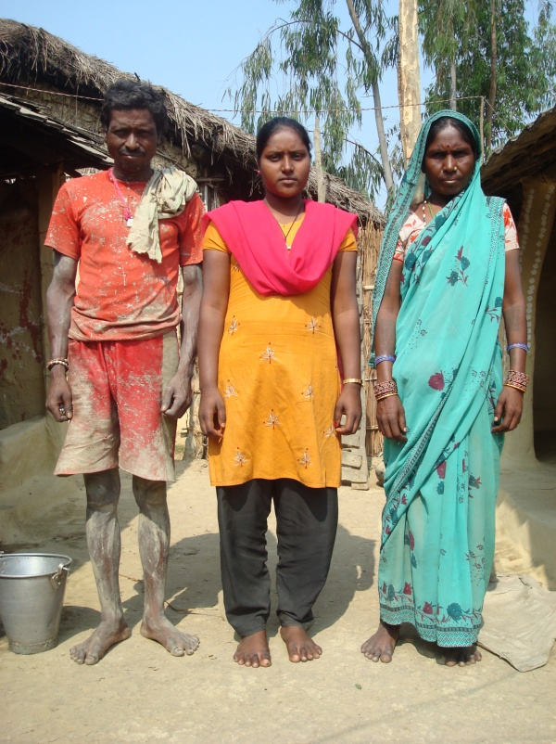
wg'iff lhNnfsf] wg'iff uf]ljGbk'/ uf=lj=;= df j:g] !& jif{ sL sdnL s'df/L ;bf d';x/ ;d'bfos} klxnf] P;= Pn= ;L= kf; ug{ ;kmn 5fqf x'g . pgL ut jif{ wg'if hgtf dfWolds ljwfno wg'iffwfd jf6 lålto >]0fLdf P;= Pn= ;L= plt0f{ eO{ ;Dk'0f{ d';x/ hflts} xf};nf j9fpg ;kmn ePsL l5g\ .
sdnL s'df/L @))% df PS;gP8 g]kfn sf] ;fdm]bf/Ldf ;dfh ljsf; ky åf/f ;+rflnt ;d'bflos ;zlQms/0f sfo{qmd cGtu{t ul7t jfn snjsf] cWoIf klg jg]sL l5g\ . pgL jfn clwsf/, jfn ljjfx / afn lzIff cleofg sfo{qmdx?df ;xeflu x'g'sf] ;fy} cWoIfsf] bfloTj lgjf{x ub}{ cfkmgf] ufpF 6f]ndf oL sfo{qmdx?sf jf/]df 5nkmn ub}{ cfO{/x]sL l5g\ .
pgsf] of] ;kmntf pgL !# jif{sf] pd]/df sIff & df k9b} ubf{ ljjfxsf] k|:tfj cfpFbf ;dfh ljsf; ky åf/f ;+rflnt ;zlQms/0f sfo{qmdsf] k|efjn] ubf{ jlxisf/ u/]sfn] P;= Pn= ;L= kf; ug{ ;Dej ePsf] xf] . gq pgL klg cGo jfnjflnsf dm} jfn ljjfxdf k/L k9fO{ jf6 jl~rt x'g] lyO{g . xfn pgL jfn ljjfx lj/f]w ;ldltdf klg ;lqmo ?kdf ;xeflu eO{ jfn ljjfxsf] lj?4df k|rf/ k|;f/ ug{ yfn] sL l5g . pgn] cfk\mgf] / l5d]sL ufpFsf] ;+u} k9b} u/]sL # hgf s]6Lx? k'gd ;bf, ;fjLqL l;x / /fwf l;+xsf] ljjfx /f]Sg ;d]t dbt ul/g\ . jfn ljjfxsf] k|;Ëdf pgL elG5g, …dw]zL 5f]/Lsf] ;j} eGbf 7'nf] zq' eg]sf] jfn ljjfx g} xf]Ú . jfn ljjfxn] ubf{ dw]zLsf w]/} 5f]/Lx? k9fO k'/f gu/L ljWofno 5f]8g jfWo ePsf y'k|} pbfx/0fx? b]vfpFl5g\ pgL .
P]nfgL hUufdf j;f]jf; / b}lgs Hofnf dhb'/L u/]/ vfg] kl/jf/df x's]{sL sdnLsf] lzIff k|ltsf] ;kmntfdf pgsf] kl/jf/sf] klg 7"nf] xft /x]sf] 5 . sdnLnfO{ k9fpgsf lgDtL pgsf a'jfn] tf;, h'jf, /S;L ;j} 5f]8] / ;dfh ljsf; kysf] ;xhLs/0fdf ;+rflnt ;d'xsf] ;b:o jgL C0f lnO{ P;= Pn= ;L=;Dd 5f]/L nfO{ k9fpg ;kmn ePsf] cfdf cgf/ b]jL ;bf jtfpFl5g . d';x/n] k9g ;Sb}gg, k9g'x'Gg eGg] s'/f d';x/sf] lgwf/df n]v]sf] 5}g, d';x/sf] 5f]/f5f]/LnfO{ k9fpg ;j}n] ;xof]u / ;Nnfx ug'{k5{Ú cfkmgf] ;kmntf tyf kl/jf/sf] ;xof]u jf6 pT;flxt ePls sdnLn] elgg\ , lzlIfsf jg]/ ;dfh ;]jf ug]{ OR5f AoQm ul5{g\ .
cf}krfl/s lzIff
;j}nf uflj; j8f g+= * df Pp6f k|fylds ljBfnosf] :yfkgf ePsf] 5 . blntx?sf] k|of;n] blntx? åf/f blntx? s} nflu ;+rflnt of] ljBfnon] blntx?sf] ul/dfnfO{ prfn]sf] 5 . j8f g+= * /fd j:tLdf ;+rflnt hgd'lv lzIff s]Gb|df 5nkmn eof] . ljBfno hfg] blntx?sf] jfnjflnsfsf] ;+Vof Hofb} sd 5 . ufpFsf blnt afnjflnsfx?nfO{ s;/L k9fpg] < dlxnfx?n] ufpF glhs}sf] s/Lj $ s7\7f P]nfgL hUufdf ljBfno :yfkgf ug]{ lgisif{ lgsfn] kl5 pgLx?n] k'?ifx?;=u klg 5nkmn u/] . To; kl5 ljBfno :yfkgfsf] k|of; cf/De eof] . /fd 6f]nsf ;d'bfox?n] :yfgLo kf6L{sf g]tfx?;+u ;xof]usf] nflu cfu|x u/] . :yfgLo g]tfx?n] pgLx?n] 3f]if0ff u/]sf] ;lxbsf] gfddf ljBfno vf]Ng] eP ;xof]u ug]{ k|:tfj /fv] / To;nfO{ /fd ;d'bfon] :jLsf/ klg u/] . To; kl5 ljBfno :yfkgf ug]{ sfo{df /fd ;d'bfonfO{ :yfgLo g]tfx?n] lbnf]Hofgn] ;xof]u u/]sf] 5 .
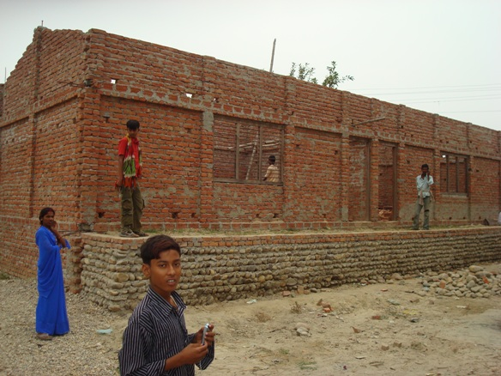
@)^$ ;fn d+l;/ ! ut] :yfkgf ePsf] of] ljBfnosf] gfd xf] >L ;lxb zDe" /fli6«o k|flj ;j}nf . of] ljBfno ejg lgdf{0f ug{ ? %) xhf/ uflj;jf6, ! nfv lhNnf ljsf; ;ldltjf6 $ nfv #% xhf/ lhNnf ljsf; ;ldlt cgtu{tsf] u/LjL lgjf/0f sf]ifjf6 / lhnnf lzIff sfof{nojf6 ;f9] % nfv /sd / ;fdfu|Lx? ;xof]u ldn]sf] 5 . * nfvsf] nfutdf ljBfnodf $ j6f kSsL sf]7f ag]sf] 5 . o; ljBfnodf nueu @)) hgf blnt 5fq5fqfx? Kl9/x]sf 5g\ eg] ljBfno Joj:yfkg ;ldltdf ( hgf g} blnt 5g\ . @ hgf lzIfsfs] b/jGbL 5 eg] @ hgfnfO{ lghL >f]tjf6 yf]/} kfl/>lds lbP/ lzIfssf] ?kdf /flvPsf] 5 . ;j}nf jhf/sf hflgkmsf/x?n] eg] hgd'lv lzIff s]Gb|sf ;xhstf{ lzj s'df/ dx/fsf] clålto of]ubfg /x]sf] 5 of] ljBfnosf] :yfkgfdf . ;d'bfon] ljBfno :yfkgfdf lbPsf] ;xof]usf] nflu :yfgLo /fhlglt bnsf g]tfx?sf] klg k|z+;f u/]sf] 5 .
;j}nfsf] blnt j:tLdf ljBfnosf] lgdf{0f eO{/x]sf]
sfof{no;+u ;Dks{ a9fpg 7'nf] ;xof]u u/]sf] ;d'bfon] pRr d'Nof+sg u/]sf 5g\ .
of] ljBfno :yfkgfn] ubf{ /fd j:tLdf lzIffsf] ;jfndf r]tgfsf] nx/ cfP h:t} ePsf] 5 x/]s 3/sf jfnjflnsf ljBfno uPsf 5g\ .

vfB tyf e"ld clwsf/

;f]8]k / PS;gP8 g]kfnsf] ;fem]bf/Ldf ;+rflnt cleofg leq vfB tyf e"ld clwsf/ klg kb{5 . o; lyd cGtu{t eP u/]sf sfo{x? / To;jf6 k/]sf c;/ tyf k|efjx?nfO{ dfkg ug]{ lgDg cfwf/x? to ul/of] .

- u/Lj, blnt tyf dlxnfx?sf] e"ld dfyLsf] clwsf/ :yflkt u/fpg ePsf cleofgx? .
- Hofnf j[l4sf nflu ul/Psf cleofg tyf To;sf] glthfx? .
- 3/jf;sf] ;'/Iff tyf hldgsf] :jldTj k|fKtLsf] nflu ul/Psf k|of;x? .
- /f]huf/ ;[hgf ug{ ul/Psf k|of;x? .
- k|sf]k Joj:yfkgsf nflu ul/Psf k|of;x? .
- s[lifdf ;'wf/sf nflu ul/Psf k|of;x? .
- ;+u7g
;xsf/L

;f]8]ksf] kxnsbdL / ;xhLs/0fdf sfo{If]qdf % j6f ;xsf/L ;+:yfx? v'n]sf] / btf{ ePsf 5g\ . tL ;xsf/Lx?sf] ;'?jft b]lv g} ;f]8]kn] ;xhLs/0f ub}{ cfPsf] 5 . % j6f ;xsf/L ;+:yfdf clxn];Dddf sl/j !) nfv hlt k'FhL ;+slnt ePsf] 5 . kfFrj6f ufpFdf s/Lj #%) 3/w'/L ;+nUg 5g\ . ;j} ;xsf/Lx?sf] u7g / g]t[Tj dlxnfx?n] lnPsf 5g\ . sfo{If]q leq} dlxnf ljsf; zfvf wg'iff / ;d'bfon] cfkm\g} k|of;df u/L bh{gf} ;xsf/Lx? vf]n]sf 5g\ . t/ ;f]8]ksf] ;xhLs/0fdf v'n]sf ;xsf/Lx?df blnt , / dlxnfx?sf] afx'No 5 . ;f]8]ksf] cu'jfO{df ul7t # j6f ;xsf/L ;+:yfx?n] g]kfn ;/sf/jf6 lbO{g] cg'bfg /sd ? Ps nfv k|fKt u/]sf 5g\ .

;xsf/Lsf] pknlJw M

- ? b; xhf/;Ddsf] C[0f lng ;b:ox?n] lwtf] /fVg gkg]{ / cGoq C[0f vf]Hg hfg gkg]{ dlxnfx?n] atfP . Ps dfgf rfdn 3l6 x'bf klg u}/ blntsf] jf ;fx'sf] 3/df dfUg hfg' kg]{ afWotfjf6 xfdL d'Qm eof}+ eg]/ ;xsf/Lsf ;b:o dlxnfx?df kl/jt{g cfPsf] 5 .
- ;xsf/Ljf6 C[0f lnP/ v'b|f k;n yfKg] / To;jf6 hLljsf wfGg d2t k'u]sf] 3/ kl/jf/sf] ;+Vof b'O{ bh{g hlt 5 .
- dlxnfx?n] ;xsf/L dfkm{t /fi6« a}+sjf6 ;:tf] Jofhdf C[0f lnP/ nufgL k|j4{g ug]{ / /fHosf] >f]t dfyL kx'Fr j[l4 ug]{ nIo lnPsf 5g\ . h;sf] nflu s]xL cem ;do nfug ;S5 .
- ;xsf/L cleofgn] ubf{ dfl;s ;os8f % k|ltztdf C[0f lbg] ;fx' dxfhgx?n] C[0fsf] JofhnfO{ # k|ltztdf emf/]sf 5g\ .
- u/Ljsf] xftdf k'FhL k/]sf] 5 .

;fx' dxfhgx?n] Jofh b/ 36fP , ;fKtflxs ls:tf k||0ffnLsf] C[0f klg 36bf] .

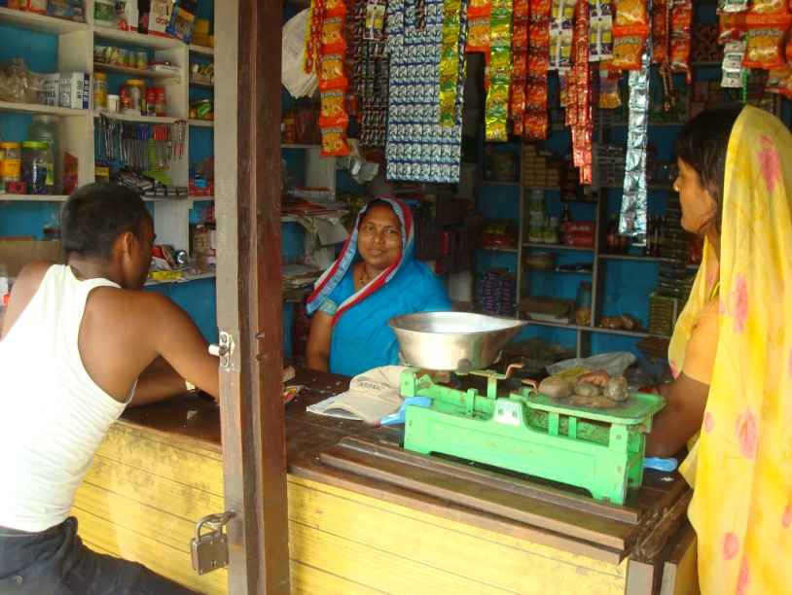
;xsf/L u7g / ;+rng ePsf] :yfgx?df :yfgLo ;fx' dxfhgx?n] ;os8f % k|ltzt dfl;s Jofhb/df nufpg] u/]sf] C[0f lng]x?sf] ;+Vofdf sdL cfPsf] 5 . C[0f lng]x? 36] kl5 ;fx' dxfhgx?n] ;os8f % jf6 ;os8f # k|ltztdf Jofh b/nfO{ emf/]sf 5g\ . lwtf] g/fvL C[0f g} gkfO{g] . t/ clxn] !) xhf/sf] uhf]{ 6fg{ ;fx' dxfhgsf] 3/df wfpg] jfWotf x6]sf] 5 . cfkm\g} ;xsf/Ln] ljgf lwtf] @) xhf/;Dd C0f t'?Gt} lbG5 . 3'; v'jfpg' klg kb}{g . To;}u/L ;d'x u7g u/L ;fKtflxs jf kflIfs ?kdf ls:tf a'emfpg] u/L C[0f lbg] n3' ljQ ;+:yfx? klg v'lDrb} uPsf 5g\ . Pp6} /sdnfO{ jif{df @% :yfgdf C[0f k|jfx ug]{ / ;j} lt/jf6 Jofh c;'nL ug]{ n3' ljQ sfo{qmd ;+rfng ug]{ ;+:yfx?nfO{ lj:yflkt kfb}{5g\ ;xsf/Lx?n] . pdf k|]dk'/ @ sL rGb/ ofbj elG5g\ s]xL jif{ leq} ;fx' dxfhgnfO{ lj:yflkt kf5f}{ xfdL .
dlxnf ;fdflhs ljsf; C[0f tyf jrt ;d'x pdf k|]dk'/sL ;'ldqf ;fx elG5g\ a}b]lzs /f]huf/df hfg ? ! nfv;Dd C[0f rflxG5 . Toltj]nf t ;fx' dxfhgsf] 3/df wfpg} k5{ . lsgsL xfd|f] ;xsf/Ldf clxn] Tolt 7'nf] k'FhL 5}g . t/ xfdL k'FhL a9fpb} nu]/ a}b]lzs /f]huf/df hfg]x?nfO{ klg ;:tf] Jofh b/df C[0f lbg] nIo agfpFb} 5f}+ .

u/Ljsf] xftdf k'u]sf] k'FhLn] hLljsf ;lhnf] eof]
dfnf ;fx $) jif{sL eO{g\ . ^ hgfsf] kl/jf/nfO{ yf]/} hldgsf] pTkfbgn] vfg k'Ub}g . t/ pgn] ;'? u/]sf] d'/xL , rk , sr/Lsf] k;nn] cfDbfgL yKg yfn] kl5 jif]{gL @% xhf/ eGbf clws cfDbfgL ylkPsf] 5 . kl/jf/sf ;b:ox? v';L 5g\ . dfnf ;fx xn'jfO{ hfltsL x'g\ / pgsf] xftdf vfg] kl/sf/x? agfpg] lzk 5 . dfq k'FhLsf] cefj lyof] h'g k'/f ul/lbof] cfkm" h:t} dlxnfx?n] ldn]/ vf]n]sf] ;xsf/Ln] .
pdf k|]dk'/ @ df % jif{ cuf8L v'n]sf] hgd'lv lzIff s]Gb|jf6 ;+ul7t dlxnfx?n] C0f jrt sfo{qmd ;+rfng ub}{ To;nfO{ ;xsf/Ldf kl/0ft u/] . clxn] ;xsf/Ldf s"n @ nfv jrt ;+sng u/]sf] 5 / ;j} /sd cfkm\gf ;b:ox?nfO{ g} nufgL u/]sf] 5 . ;xsf/Ljf6 cfnf]kfn] u/L xfn;Dd &* hgfn] C0f lnPsf] / lt/]sf] dlxnfx? uf]/jfGtLt 5g .
oxL ;xsf/Ljf6 !) xhf/ C0f lnP/ dfnf ;fxn] d'/xL sr/Lsf] k;n ;'? ul/g . :yfgLo ?kdf nfUg] xf6 jhf/df pgL 6f]s/Ldf lnP/ d'/xL sr/L j]Rg hflG5g\ . ? %)) b]lv &)) ;o;Ddsf] laqmL x'g] u5{ . xf6 jhf/sf] lbg !%) b]lv @)) ;Dd kmfO{bf x'g] dfnfn] eG5g\ .
of] Jofj;fo ug{ yfn] b]lv dfnfsf] 3/df v'l;ofnL 5fPsf] 5 . o;/L v'b|f k;n ug}{ dfnf PSnL dlxnf xf]O{gg\ . pgL h:t} ;xsf/Lsf bh{gf} ;b:o dlxnfx?n] v'b|f Jofkf/ ug{ yfn]sf / kl/jf/sf] hLjLsf wfg]sf 5g\ .
k|d]Zj/sf] lhjgdf 5fof] Hof]tL
Pp6f ;fwf/0f t/ d]xg]tL e"ldxLg ls;fg k|d]Zj/ dxtf]n] hldGbf/sf] v]t ef8fdf lnO{ ;fnsf] s¶fsf] kfFr ;o lt/L hDdf !) s¶f le6g hUufdf ljleGg lsl;dsf df};dL tyf a]df};ld t/sf/Lx? pahfpg] ub{5g . h}ljs k|ljlw åf/f v]lt ug]{ tl/sf / o;jf6 x'g] kmfO{bf x? jf/] ;dfh ljsf; ky, g]kfnn] Ifdtf clej[l4 ;DjGwL lbOPsf tlndx? jf6 l;s]/ nfu' ul//x]sf k|d]Zj/ dxtf] afx|} dlxgf t/sf/L j]r]/ ;fnsf] ?= !@%))) b]lv ?= !%)))) ;Ddsf] t/sf/L a]Rg] ub{5g\ .
s[ifs ;d'xsf cWoIf kbdf ;d]t sfo{/t k|d]Zj/ dxtf] cfk\mgf ;d'xsf ;xeflux?nfO{ jrt ug]{ u/fpg] t/sf/L v]lt ug]{ tf}/t/Lsfx? a'dmfpg] ub{5g\ . h;n] ubf{ v]ltug]{x?sf] ;+Vof @% ePsf] / t/sf/L v]lt nueu &* s¶f hUufdf ul//x]sf] n] lhNnf s[lif sfof{nojf6 klg ;do ;dodf tflnd lbg], ljp ljhg lbg] / l;rfO{sf ;'ljwfx?df df]6/, af]l8{ª / :k| pknAw u/fO{ lbPsf 5g . / cfw'lgs tl/sfn] s[ifsx? t/sf/L pAhfpg] ub{5g .
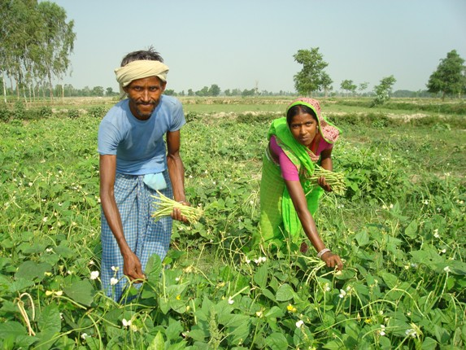
sfwdf xnf] / xftdf v'kL{ lnP/ k|foM ;do v]tdf g} ljtg] ub{5g . OdfGbf/ / d]xgtL ls;fg k|d]Zj/n] cfkm} ufO{, e};L / uf]? kfn]sf 5g\ . tL uf]j/, uf}t, k/fn, 3fF;kftx? vfN8f]df xfNg] ub{5g . / dn tof/ u/L v]tdf xfng] ub{5g . ufO{ / e};Ljf6 b'w j]rL dlxgfsf] ?= #))) b]lv ?=#%)) ;Dd sdfpg] u5{g\ . cfkmgf] v]tdf nufPsf t/sf/Lx? 6df6/, e06f, sf]aL, cfn', t/a'h, lkofh, n;'g, jf]/L cflb pahfpg] ubl5{g\ . df ahf/jf6 laiflb cf}ifwL lsg]/ Nofpg'sf] ;§f ToxL 6df6/sf] kftjf6, lgdsf] kft / bgf ufO{ uf]?sf] uf}t -d'q_, v}lgsf] 8f7 jf6 ljiffwL tof/ u/L t/sf/L jflndf nfu]sf ls/f /f]ux?jf6 jrfpgsf] nflu ljifflw 5g]{ ub{5g . / cfk\mgf ;d'xsf ;xeflux?nfO{ -5/l5d]sLx?nfO{_ klg ToxL t/Lsfx? ckgfpg ;Nnfx ;'dmfa lbg] ub{5g .
cfkmgf] t/sf/L v]ltdf af]/L 6LkL/x]sf k|d]Zj/ dxtf] / pgsf] >LdtL
wg'iff lhNnfsf] wg'iff uf]ljGbk'/ uflj; jf8{ g+= ^ df a:g k|d]Zj/ dxtf] sf] 3/df # 5f]/f @ 5f]/L / @ hgf cfkm} u/L hDdf & hgfsf] kl/jf/ /x]sf 5g\ . gfd / bfd b'j} sdfO{ /x]sf k|d]Zj/n] eG5g\ ;dfh ljsf; ky, g]kfnn] dnfO{ ædf5f dfu]/ vfg] xf]O{g, df5f df/]/ vfg] tl/sf l;sfPsf 5g\Æ. o; kfln cfn'sf] emf/ -af]6_ af6 sDtLdf 8]9 lsnf] pTkfbg ePsf] pxfFn] bfjL ub{5g\ . oL ;a cfDbfgL af6 cfkmgf] 5f]/f 5f]/Lx?nfO{ clxn] :s'ndf k9fpg'sf] ;fy} lhjg wfGg cToGt ;lhnf] ePsf5g . To;}sf] cfDbflgaf6 clxn] ckmgf] gfddf ! laUxf v]t klg lsg]sf 5g . k|d]Zj/ Ho'n] eG5g\ ;dfh ljsf; ky, g]kfnn] ubf{ d]/f] lhjgdf Hof]tL g} 5fPsf] 5 .
ckf+usf] hLljsf / cfTd;Ddfg
pdf k|]dk'/ @ sf /fd ljnf; ;fx ckf+u x'g\ . pgsf] v'6\6f kf]lnof]sf] lzsf/ ePsf] 5 . pgL 3;]{/ lx85g\ . t/ pgsf] xftdf ljB'lto ;fdfgx? dd{t ug]{ lzk 5 . pgn] ;xsf/Ljf6 kfFr xhf/ ljgf lwtf] C[0f lnPsf 5g\ . 3/ d} ljB'lto ;dfg dd{t ug{ yfn] kl5 pgn] dfl;s @ xhf/ cfDbfgL ug{ yfn]sf 5g\ . pgL eG5g\ kf6k'hf{ lsGg] k'FhL lyPg\ . ;xsf/Ln] ;lhnf] agfO{ lbof] . pgn] ljjfxf]T;jx?df ef8fdf lbg ;fpG8 l;:6d klg /fv]sf 5g\ . To;jf6 klg pgnfO{ dgUo cfDbfgL x'G5 . cfkm} u/L vfg yfn] kl5 kl/jf/ dfyLsf] af]em klg xn'sf ePsf] 5 / dnfO{ klg cfTd ;Ddfg a9]sf] cg'e'lt ePsf] 5 . ;xsf/Lsf] dfWodjf6 u/Ljsf] xftdf k'FhL k'¥ofpg ;kmn ePsf] 5 .
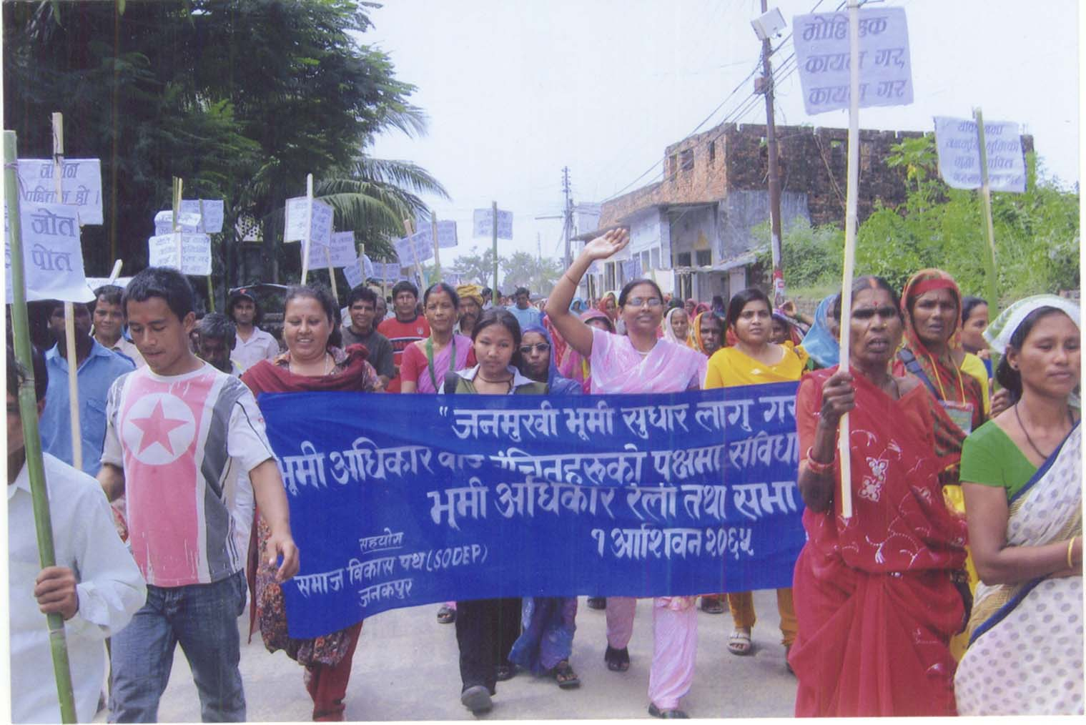
e"ld clwsf/sf] dfu ub}{ k|= d= nfO{ 1fkgkq
c;f]h ! ut] wg'iffsf e"ldxLgx?n] ljleGg dfux? ;lxt k|wfgdGqLnfO{ lhNnf k|zf;g sfof{no dfkm{t 1fkg–kq a'dmPsf] 5 .
1fkg–kqdf e"ldxLgx? nfO{ e"ld pknAw u/fpg' kg]{, e"dflkmofsf] Psflwsf/ cGTo x'g'kg]{, h;sf] hf]t p;}sf] kf]tsf] Aoj:yf x'g'kg]{, qmflGtsf/L e"ld ;DjGwL P]g sfo{fGjog x'g'kg]{ h:tf dfu ul/Psf] 5 .
o; cl3 :yflgo afx|la3f /Ëe"ld d}bfg jf6 ;os8f}+sf] ;+Vofdf ;xeflu /x]sf] e"ldxLgx?sf] /}nL hgsk'/sf] gu/sf] kl/qmdf ul/ lhNnf k+zf;g sfof{nodf cfP/ 1fkg–kq a'dmfPsf lyP . dlxnf k'?ifsf] Aofks ;xeflutf /x]sf] pQm /}nLdf e"ld clwsf/ ;DjGwL ljleGg gf/fx? klg nufPsf lyP .
Ps;gP8 g]kfnsf] ;fdm]bf/Ldf ;dfh ljsf; ky / wg'iff ;]jf ;ldltsf] ;xlhs/0f åf/f u7Lt lhNnf e"ld clwsf/ d+rsf] ;lqmotfdf cfof]hgf ul/Psf] pQm sfo{qmddf k'?if eGbf a9L dlxnfsf] ;xeflutf /x]sf] lyof] . qmflGtsf/L e"ld ;'wf/ P]g nfu' u/ . hf]txfsf] clwsf/ sfod u/ h:tf gf/f nufPsf] lyof] .
k|wfgdGqLnfO{ ;Daf]wg ul/ n]lvPsf] pQm 1fkg–kq u|xg ub}{ wg'iffsf k|d'v lhNnf clwsf/L /fdz/0f lrdf]/Lofn] cfh} k|wfgdGqL sfof{nodf k\mofS; dfkm{t k7fpg] atfpg' eof] . wg'iffsf] w]/} h;f] uf=lj=;=df xhf/f} AolQmx? P]nfgL hUufdf a;f]jf; ul//x]sf 5g\ . pgLx?sf] 3/sf] hUuf btf{ x'g'kg]{ dfu u/]sf lyP .
uf=lj=;= pdfk]|dk'/df hldgbf/ ;Ltf/fd dxf;]7n] #)–#% jif{ klxnf g} lagf n]vk9 hldg ljlqm u/L e"ldxLg x?nfO{ cfkmgf] hldgdf j;f]jf; ug{ lbPsf lyP . j;f]jf; ub}{ cfPsf e"ldxLgx?n] cfkmgf] gfpFdf hUuf btf{ ul/ lbg' k6s–k6s eGbf klg cfn6fn ub}{ k5L glbg] dg;fon] clxn]sf] d'No j/fj/sf] /sd lbP dfq} hUuf gfd;f/L u/L lbG5' eGg yfn] . To;sf] nut} e"ld clwsf/ d+rsf] kxndf e"ldxLgx? åf/f l;tf/fd dxf;]7sf] 3/df wgf{ lbO{ 3]/fjGbL u/L bjfa lbbf ;dfhsf] /f]xj/df hUuf btf{ ug]{ ;xdtL eof] . kmnt M @@ hgf a;f]jf; ug]{ e"ldxLgx?n] Ps ljuxf bz s¶f hUuf btf{ u/fpg ;kmn ePsf 5g ;fy} jfsL a;f]jf; u/L /x]sf e"ldxLgx?sf] hUuf btf{ x'b} u/]sf] 5 .
/]ld6fG;sf] sf/0f km:6fof]

a}b]lzs /f]huf/df hfg]x?n] k7fPsf] /]ld6fG;sf] k|efj jrt ;d'x / ;xsf/Ldf b]lvG5 . h'g 3/jf6 k'?ifx? j}b]l;s /f]huf/df uPsf 5g\ To; 3/sf dlxnfx? ;d'xdf cTolws cfj4 5g\ . pdf k|]dk'/ @ df ;+rflnt ;xsf/Ldf &* hgf ;b:o 5g\ . tL dWo] #% 3/jf6 k'?ifx? a}b]lzs /f]huf/df uPsf 5g\ .

Hofnf j[l4 cleofg M

;j}nfsf] /fd 6f]n , pdf k|]dk'/sf] @ g+= j8f , wg'iffwfdsf] & g+= ;/;f ufpF / wg'iff uf]ljGbk'/ * sf] ;'Gb/k'/df blnt u/Ljx?n] @)^# / @)^$ ;fndf Hofnf j[l4 ug'{ kg]{ dfu ;lxt x8tfn u/] . s[lif dhb'/ oL blnt u/Ljx?n] c;f/sf] dWo lt/ hltj]nf wdfwd /f]kfFO{sf] j]nf x'G5 l7s ToxL j]nf x8tfnsf] 3f]if0ff u/]sf]n] e"ldkltx? cflQP . e"ldkltx?n] yf]/} tyf ;fgf] cfsf/sf] k|lt/f]w klg u/] t/ hLt u/Lj blnt s[lif dhb'/x? s} eof] . b"O{ rf/ lbg sfd jGb eof] . b"O{ tLg k6s dhb'/x?n] gf/f h'n'; klg u/] . cGTodf /f]kfFO{ gx'g] l:ylt b]v]/ e"ldkltx? Jftf{df cfP . jftf{jf6 ^ lsnf] wfg k|lt lbgsf] Hofnfjf6 * lsnf] agfpg ;xdlt eof] . gubdf sfd ubf{ b}lgs ? @)) dhb'/n] kfpg] eP . of] cleofgn] ljut @% jif{ b]lv j[l4 gePsf] Hofnfdf j[l4 u/fof] . s[lif dhb'/x? ;fdGotof jif{df @)) lbg sfd u5{g\ . o; lx;fjn] k|lt dhb'/ jflif{s cfDbfgLdf $)) s]hL wfg a9L dhb'/L kfpg] eP . gubdf ?kfGt/ ubf{ !) xhf/ jflif{s dhb'/Ldf j[l4 eof] . cleofgn] dlxnf / k'?if Hofnf j/fj/ x'g'kg]{ c8fg lnPsf] lyof] / To;df klg ;kmntf xft k¥of] . Hofnf j[l4 cfGbf]ngdf kfPsf] ;kmntfn] u/Lj blnt s[lif dhb'/x?sf] hLljsfnfO{ ;3fPsf] 5 . s/Lj !#)) eGbf clws 3/w'/LnfO{ Hofnf j[l4 cleofgn] kmfO{bf k'¥ofPsf] 5 .

dlxnf clwsf/

dlxnf clwsf/ eGgf ;fy dlxnfx?sf] dfgj clwsf/ sfof{Gjog / cEof;sf] l:ylt sdhf]/ 5 / To;}sf] k|Tofe"ltsf] nflu ePsf k|of;x? ;fd'Gg] cfpg] u5{ . dlxnf lx+;fsf] ;Gbe{ sf]6ofpFbf slyt af]S;Lsf] gfddf s'6lk6 tyf lb;f lk;fj v'jfO{g] , jnfTsf/ , bfO{hf] sf/0fjf6 x'g] s'6lk6 , c+ue+u / xTof , bfO{hf]sf] sf/0fjf6} kltn] 5f]8]/ jf 3/ lgsfnf u/]/ cnGtf/ kf/]sf] , jx' ljjfx ,jfn ljjfx , kf7]3/ v;]/ kL8fdf k/]sf] , r]nLj]6L j]rljvg / PrcfO{eL ;+qmd0f d"n ?kdf ;fd'Gg] cfpF5g\ .

- dlxnf k'?if ;dfg Hofnfsf nflu Hofnf j[l4 cfGbf]ngs} qmddf ;jfn p7fO{Psf] / ;kmntf klg ldn]sf] 5 .
- cj aGg] gofF ;+ljwfgdf dlxnfx?sf] clwsf/ ;'/lIft ug{ s] s] Joj:yf ug'{ k5{ eg]/ dlxnfx?sf] tkm{jf6 dfu ;lxtsf] 1fkg kq ;+ljwfg ;efsL pk ;efd'v k'0f{ s'df/L z]kf{ ;dIf k|:t't u/]sf] lyof] .
- !^ lbg] dlxnf lx+;f lj?4sf] lbj;sf] qmddf ;f]8]kn] cfkm\gf] sfo{If]qdf ljleGg r]tgfd'ns ¥ofnL , ;ef / hg kl/rfngsf] sfd k|To]s jif{ ub}{ cfPsf] 5 . gf/L lbj;sf] lbg ¥ofnL / ;]ldgf/ sfo{If]q / lhNnf ;b/d'sfddf u/]sf] lyof] .
- dlxnf dfyL x'g] 3/]n" lx+;f lj?4 7fpF 7fpFdf leQ] n]vg ul/Psf] 5 .
- ufpF :t/df dlxnf clwsf/ d~rsf] u7g * :yfgdf ul/Psf] 5 / lhNnf dlxnf clwsf/ d~rdf klg tL ;d'xx?nfO{ hf]l8Psf] 5 .
- jfn clwsf/ s]Gb|df jflnsfx?sf] ;xeflutsf] kIf /fd|} 5 .
- ;xsf/Ln] dlxnfx?sf] cfly{s clwsf/sf nflu ePsf] /fd|f] sfdsf] k|ltlglwTj u/]sf] 5 .
- dlxnf jx'n hgd'lv lzIff s]Gb|x?df dlxnf r]tgfnfO{ ltvfg]{ sfd /fd|/L ePsf] 5 .
u/Lj , blnt / dlxnfx? jf6 :yfgLo g]t[Tjsf] ljsf;
O{Gbn ;bf , km"n s'df/L ;bf , t]h gf/fo0f bf; , ;/Ltf ;fx , h;f]lwof ;bf , cg'k|fu d08n , ljN6' dx/f , lzjf] d08n , km'nf] b]jL l;x+ / hLj5L ;fx nfO{ ;dfhdf g]t[TjbfoL e"ldsfsf] nflu sfo{qmdn] ;zQm ?kdf :yflkt u/fPsf] 5 .
:jf:Yo clwsf/
;f]8]ksf] sfo{If]q leq ;j}nf / wg'iffwfddf @ j6f k|fylds :jf:Yo s]Gb| 5 . of] s]Gb|x?df PdljljP; 8fS6/sf] b/jGbL 5 . @$ ;} 306f cfsl:ds ;]jf / k|;'lt ;]jf klg 5 . pk:jf:Yo rf}sLx? klg 5 . :jf:Yo ;]jf s]Gb|x?df ;d'bfosf] vf; u/L sdhf]/ ju{sf] kx'Fr j[l4sf nflu ;f]8]kn] u/]sf] k|of;jf6 ;d'bfo cTolws nfeflGjt ePsf] 5 .

PS;g P8sf] qm;sl6+u O{lgl;ol6e;+u cGt/ ;DjGw M
k|sf]k Joj:yfkg

- # jif{ cuf8L -@)^$ ;fndf _cfPsf] af9Lsf] rk]6fdf k/]sf ;d'bfox?sf] Ifltsf] tYof+s lng] sfo{ ePsf] lyof] .
- wg'iff uf]ljGbk'/ j8f g+= & ;'Gb/ 6f]ndf $$ 3/ d';x/ ;d'bfo /x]sf] j:tL jf9Lsf] rk]6fdf k¥of] . Toltj]nf ;f]8]kn] jf9L lkl8t ;d'bfonfO{ p4f/ u/L ;'/lIft :yfgdf /fv]sf] , /fxt :j?k vfBfGg / nQf sk8f jf8]sf] lyof] . bf]>f] r/0fdf ;d'bfonfO{ 8'jfgdf kbf{ p4f/ ug]{ tf}/ tl/sf l;sfpg] tflnd / /:;L , nfO{km Hofs]6 h:tf ;dfu|L klg pknJw u/fPsf] 5 . To;} u/L /fxt :j?k kf}li6s cfxf/ ljt/0f , Ifltu|:t 3/sf] dd{t , cfo cfh{gsf nflu jfv|f / j+u'/ ljt/0f ul/Psf] 5 .
- sfo{If]qsf] % uflj;df ;+s6fled'v ;d'bfosf] tYof+s ;+sng / ljZn]if0f ul/of] .

hg jsfntjf6 :yfgLo, lhNnf, If]q / /fli6«o gLltdf k|efj M

clwsf/d'lv cleofgn] /fHonfO{ sdhf]/ ju{sf] lxt cg's'n gLlt agfpg / sfof{gjog ug{ hf]8 lbG5 . ;f]8]ksf] x:tIf]k jf bjfjsf sf/0f ;/sf/n] , lhlj;, uflj; / hgsk'/ gu/kflnsf gLltut lg0f{o u/L sdhf]/ ju{sf] lxt cg's'n sfo{ u/]sf] 5 .
;f]8]ksf] cleofgn] ubf{ g]kfn ;/sf/n] gful/stf P]g @)^# agfP/ nfu" ug{ afWo eof] . gful/stf ljt/0f lzjL/ v6fO{of] / g]kfnsf] k|d'v /fli6«o ;d:of g} ;dfwfg eof] . ;f]8]k;+u /fHon] u/]sf] lnlvt ;Demf}tfsf] b:tfj]h 5 . :yfgLo :t/df :yfgLo ;/sf/n] cleofgsf] bjfjn] ubf{ gLltdf k/Ljt{g u/]sf] / gofF gLlt klg agfPsf] 5] . hgsk'/ gu/kflnsfdf 3]/fp u/]/ bjfj lbPsf] lyof] . dfu lyof] s"n ljsf; jh]6sf] #% k|ltzt blntsf nflu ljlgof]hg ug'{ kg]{ . bjfjsf sf/0fn] gu/kflnsfn] cleofgsdL{ blntx?;+u ;Demf}tf u¥of] /
gful/stfsf] nflu ;f]8]kn] u/]sf] cleofgsf] bjfjn] ubf{ g} gful/stf P]g @)^# ag]sf] / gful/stf lzjL/ b]z e/L vl6Psf] lyof] . dw]; cfGbf]ngsf] k|efjn] klg of] kmlne"t ePsf] xf] . t/ gful/stf h:tf] ;+j]bglzn / /fli6«o ;jfndf ;f]8]kn] p7fPsf] cleofgn] of] ;jfnnfO{ /fli6«o /fhgLltsf] d"n k|jfxdf Nofpg / /fHosf] u+eL/ Wofgfsif{0f ug{ dxTjk'0f{ e"ldsf v]n]sf] xf] .
gful/stfsf] ;jfndf cleofg p7fPsf] eGbf klg gful/stf lzjL/df ;d'bfonfO{ gful/stf agfpg sfuhL k|s[of k'/f ug{ ;d'bfonfO{ u/]sf] ;xof]u / gful/stf cleofgdf ;f]8]kn] v]n]sf] e"ldsf pTs[i6 pkNjwL 5 . of] cToGt ;kmn cleofg lyof] .
hLjg d'vL lzIffn] Nofof] rdTsf/
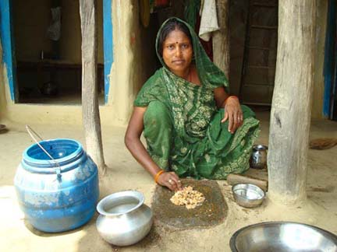
s'jfFsf] Eofu'tf h:tf] a:g' k/]sf] lzjf] d+8n clxn] ;d'xsf ;xeflux?nfO{ cIf/ lrgfpg] ub{l5g . @))^ ;fndf :yfkgf ePsf] lhjg d'lv lzIff k9]sL lzaf] d+8n clxn] % jif{ b]lv rnb} cfO{/x]sf hDdf (% hgf dlxnf z]o/ ;b:o /x]sf] dlxnf ax'2]Zo ;xsf/L ;+:yfsf] cWoIf jg]sL l5g\ eg] lhjg d'lv sIff ;+rfng u/L 5nkmn ug]{ ul5{g\ . ;d'bfosf] cu'jf eP/ lrlgg] lzaf] d+8n ;d'bfosf cleefjsx?sf] hGd btf{, ljjfx btf{, d[To' btf{, 36gf btf{ agfpgdf d2t ug]{ ul5{g . ;d'bfodf ePsf] lx+;f, 36gfx?nfO{ :yflgo :t/ nufot l;l8of] sfof{no ;Dd btf{ u/fO{ lg0ff{os txdf k'ufpgsf] nflu dlxnf ;d'xsf ;xeflux?nfO{ kl/rfng ul5{g eg] uflj; :t/Lo ldl6ª, uf]i7L, j}7sdf ;xeflu eO{ ;'dmfj ;Nnfx /fVg] ul5{g\ .
hLjg d'lv sIffsf] k|efjn] lzjf]sf] 3/df klt gePsf] a]nf cfkm} 6fo/ uf8fdf pv' nf]8 u/]/ cfkm} uf8f rnfO{ pv' /f6g ;Dd k'¥ofPsf] lyof] . pgsf] @ 5f]/f / @ hgf cfkm} 5g\ . 3/sf] cfDbgLsf] >f]t eg]sf] v]lt / a]kf/ 5g\ . lzaf] d+8nn] ;xsf/L jf6 ?=@%))) C0f lnO{ wfg / t/sf/Lsf] Aokf/ ul/ dlxgfsf] ? #))) b]lv ?= $%)) ;Dd sdfpg] ul5{g\ . pQ cfDbfgLjf6 lzaf] d+8n b'O{ 6} 5f]/fnfO{ wg'iffwfdsf] af]l8{Ë :s'ndf k9fpg] ul5{g\ .
wg'iff uf]ljGbk'/ uflj;sf] jf8{ g+= & df j:g] lzjf] d+8nsf] 3/sf cleefjsx?sf] bjfjdf /xL dlGb/sf] d'lt{ h:t} a:g' k/]sf] lzaf] d+8nnfO{ s]lx s'/f]sf] 1fg lyPg\ . ;dfh ljsf; ky åf/f ;+rflnt l/kmn]S6 ;]G6/ sIff ;+rflnt ePsf] ;d'xdf ;xeflu eO{ lzaf] d+8n @÷# jif{sf] cjlwdf /fd|/L n]vk9 ug{ ;Sg] ePsL d+8n 3'D6f] k|yf jf6 d'Qm ePsf 5g\ .
clwsf/d'lv cleofgn] u/LjL x6b}5 ul/df a9b} 5 .

wg'iff lhNnfsf] ;j}nf uflj; j8f g+= * df rdf/ hfltx?sf] afSnf] a;f]jf; 5 . ;j}nf ahf/;+u s'd hf]l8Psf] of] ufpFnfO{ ;j}n] rd/fxL - ckdflgt ?kdf rdf/x?sf] j:tL eGg] cy{df _ eGg] uy]{ . t/ clxn] of] ufpFsf] gfd} km]l/Psf] 5 . cj rdf/ hfltx?sf] j:tLnfO{ dx/f j:tL eGg] u5{g\ . rdf/ eGg] hflt ;'rs zJbnfO{ clt ckdflgt u/]/ pRrf/0f ul/Psf]n] rdf/ hfltx?n] cfkm\gf] y/ dx/f n]vfpg yfn]sf lyP . rd/fxLsf] ;6\6f dx/f ufpF eGg yfn]sf]df rdf/ hfltx? v';L 5g\ . o;nfO{ pgLx?n] ;Ddflgt klxrfg lgdf{0f u/]sf] cy{df lnPsf 5g\ . :jfledfg a9]sf] dx;'; u/]sf 5g\ . l;tf b]jL dx/f elG5g\ klxn] eGg] uy]{ cfh rd/fxLdf o:tf] eof] p:tf] eof] t/ cj dx/f 6f]n eg]/ ;+jf]wg u5{g\ .
hgd'lv lzIff s]Gb|df s'g clwsf/df bfjL ug]{ / s;/L xfd|f] hLjg km]l/G5 eGg] 5nkmn ub}{ hfFbf dx/f ufpF glhs} /x]sf] P]nfgL klt{ hUufdf Pp6f :s"n lgdf{0f ug{ kfP cgL xfd|f] ufpFsf ;j} jfnjflnsfx?nfO{ ljBfnodf egf{ ug{ kfP xfd|f] hLjg dfyL p75 eGg] 5nkmnsf] lgisif{ lg:Sof] . cgL pgLx? nfu] pkfosf] vf]hLdf . dlxnfx?n] ufpFsf k'?ifx? , Snjx? , kf6L{sf :yfgLo g]tfx?, ;f]8]ksf sfo{stf{x? / o'jfx?nfO{ af]nfP/ ufpF cuf8Lsf] $ s7\7f P]nfgL hUufdf :s"n agfpg] k|:tfj /fv] . :yfgLo g]tf h'u]:j/ ofbjn] pgLx?n] 3f]if0ff u/]sf] ;lxbsf] gfddf ljBfno agfpg] xf] eg] k'0f{ ;xof]u lbg] atfP . dx/fx?n] klg To;nfO{ :jLsf/ u/] .
;3if{ ;ldlt agfP/ uflj;, lhlj; / lhNnf lzIff sfof{nodf k'u] dlxnfx? . ;fydf k'?ifx? klg kl5 nfu] . ljBfnosf] :jLs[tL klg ldNof] . lhNnf lzIff sfof{nojf6 ? ;f9] kfr nfv j/fj/sf] Ans lgdf{0f ;fdfu|L , uflj;jf6 %) xhf/ / lhlj;jf6 $ nfv #% xhf/ jh]6 k|fKt ug{ pgLx? ;kmn eP .
!%) 3/w'/L blntsf @%& hgf jfnjflnsfx? of] ljBfnodf lgoldt ?kdf k9\g cfpF5g\ . clxn];Dd Ps hgf klg 8«k cfp6 ePsf] 5}g . ;j}eGbf dxTjk'0f{ s'/f t of] ljBfno ;+rfngdf cfP kl5 blnt j:tLsf ljBfno hfg] pd]/sf Ps hgf klg jfnjflnsf ljBfno jflx/ 5}gg\ . ;j} g} ljBfno hfg yfn]sf 5g\ .
!%) 3/w'/Lsf ;j} 3/sf ;Dk'0f{ jfnjflnsfx?sf] hGdbtf{ u/fO{ ;lsPsf] 5 . k|f+ufl/s dn agfpg] tflnd lnP/ bLuf] s[lifsf] nflu pgLx?n] t/sf/L v]lt cf/de u/]sf 5g\ . s[ifs ;d'xdf cfj4 blnt ufpFsf ls;fgx? jLp ljhg ;dodf gkfO{Psf]df eg] lrlGtt 5g\ .
blnt ;dfh ;xsf/L ;+:yf gfdfs/0f u/]/ ;xsf/L @)^% ;fndf btf{ u/fO{Psf] 5 . ;xsf/L ;+:yfn] ;xsf/L k;n vf]Ng ;/sf/jf6 ? ! nfv cg'bfg ;xof]u kfP kl5 ;b:ox? emg pT;fxL ePsf 5g\ . cg'bfg /sdjf6 pgLx? /;folgs dnsf] l8n/ lnP/ ;+rfng ug]{ of]hgfdf 5g\ . %@ hgf ;]o/ ;b:o /x]sf]df $* hgf dlxnfx?sf] ;+Vof /x]sf] 5 . cg'bfg / jrt /sd u/L cj @ nfv k'FhL ePsf] 5 . ;j} /sd Jofhdf C[0f nufgL ePsf] 5 . vftfkftf /fVg klg pgLx? l;4x:t ePsf 5g\ .
d/gL b]jL elG5g\ o; ufpFsf blntx? ? !) xhf/;Ddsf] C[0f lng lwtf] /fVg' kg]{ afWotf / dfl;s ;os8f % k|ltzt Jofh ;fx' dxfhgnfO{ ltg'{ kg]{ rsf]{ zf]if0fjf6 d'Qm ePsf 5g\ . To;} u/L km"n s'df/L dx/f elG5g\ Ps ;o ?k}ofsf] sfd kbf{ klg dflns eg]/ 9f]Ug hfg' kYof]{ t/ cj s;}nfO{ v';fdb ug'{ kb}{g .
;xsf/Ljf6 # xhf/;Dd C[0f lnP/ :yfgLo xf6 jhf/df r'/f k;n / t/sf/L tyf kmnkm"n k;n yfKg] blnt dlxnfx? klg Ps bh{g hlt 5g\ .
Hofnf j[l4sf] nflu rnfO{Psf] cleofgn] b}lgs @ lsnf] wfg Hofnf jfkt ylkPsf] 5 . Tof] eGbf klg blntx? hfu] . clwsf/ dfUg yfn] eGg] ;+b]z ufpFe/L km}lnPsf] 5 elG5g\ ;f]gfjtL dx/f . ufpFdf u}/ blntx?n] cj logLx?nfO{ gx]k glh:Sofp, hfu]sf 5g\ eg]sf] cfkm\g} sfgn] ;'Gg kfpFbf alnof] eP5f}+ h:tf] nfUg yfNof] ;f]gfjtLn] ylkg . xfdLn] ufpF kl/ifb 3]/fp u/]/ j}7s x'g lbPgf}+ . cgL xfd|f] dfu k'/f eof] . To;kl5 t xfd|f] klg lxDdt a9\of] . c?x? klg 8/fpFg yfn] .

dlxnf lj?4 x'g] lx+;fdf klg pgLx? n8L /x]sf 5g\ . dlxnf clwsf/ d~rn] ufpF3/df x'g] ;fdflhs 5nkmndf x:tIf]k ug{ yfn]sf 5g\ . :yfgLo af]njd d+bL/df k:gsf nflu bjfj lbof}+ . s;}n] /f]Sg ;s]g . k;]/} 5f8\of} elG5g\ dlxnf clwsf/ d~r sL cWoIf /fdtf]nf dx/f . hgd'lv lzIff s]Gb|df ePsf] ;fIf/tf cEof;n] * hgf dlxnfx? klqsf k9\g ;Sg] u/L ;fIf/ ePsf 5g\ .
;'ne zf}rfno sf] nflu jh]6 5'6\ofpg uflj;df bjfj lbg] of]hgfdf 5g\ blnt dlxnfx? .
cfTd ;Ddfg , ;fdflhs ;'/Iff , ;/sf/L ;]jf ;'ljwf tyf :yfgLo lgsfosf] jh]6 , lzIff clwsf/ , zf]if0fjf6 d'lQm / k'FhLsf] ljsf;n] :j/f]huf/ Ps ;fy ;'? ul/Psf] 5 . ufpFjf6 u/LjL 36\b} 5 t/ ul/df a9\b} 5 .
dlxnfsf] kxF'r
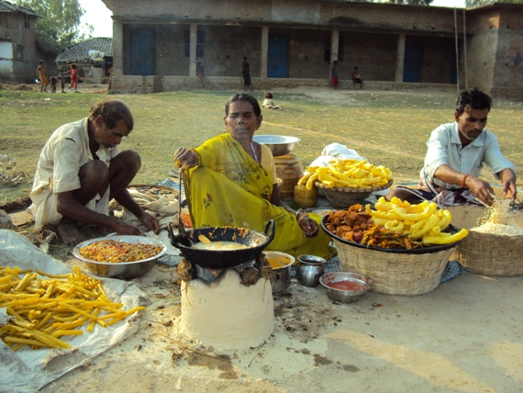
hLjgsf] %) a;Gt kf/ ul/ ;s]sL cg'k/fu b]jL d08n @))% ;fndf ;dfh ljsf; ky, g]kfn åf/f ;+rfng ePsf] hLjg d'lv sIffdf ;xeflu ePsL lyO{g . cg'k/fun] ;f] sIffdf n]vk9 ug'{sf] ;fy} dlxnf xs clwsf/ jf/] 5nkmndf ;lqmo ;xeflutf eO{ dlxgfsf] ? @% sf b/n] jrt klg uly{g . hLjg d'lv sIffsf dlxnfx? jrt sf]ifnfO{ ;+/If0f ug{ / C0f kl/rfng ug{sf] nflu @))* sf] gf]e]Dj/ dlxgfdf cg'k/fu b]jLsf] cu'jfO{df ;xsf/L ;+:yf btf{ u/fO{g\ .
dlxnfx?s} ;lqmotfdf ;+rflnt ;xsf/L ;+:yf jf6 ?= %))) C0f lnO{ kl/jf/sf lhjg rnfpg cg'k/fu b]jL d08n n] cfkmg} ufpFsf] :s'n cuf8L ;fgf] vfhf k;n ;+rfng ul/ lbgsf] ?=@%) b]lv ?=$)) ;Dd sdfpg] ul5{g\ . cfkm}n] jrt u/]sf] ;xsf/Ljf6 C0f lnO{ k;n ;+rfng ug{ ;s]sf]df pgL v';L ;fy dlxnfx?nfO{ art ug{ l;sfpl5g\ . xfn cg'k/fu b]jL ;xsf/L ;+:yfsf cWoIf eP/ ;dfln /x]sL l5g\ .
cg'k/fu b]jLn] vfhf k;n ;+rfng u/]sf] t:jL/
wg'iff lhNnfsf] uf=lj=;= e'txL k6]jf{ jf8{ g+= @ df j;5Lg\ . @ 5f]/f @ a'xf/L, @ gltgL e} ;s]sL cg'k/fu b]jL eG5Lg æklxn]—klxn] k'?ifx? e]nf ePsf] 7fpFdf hfg' x'b}g s'/f ;'Gg' x'b}gYof] . t/ cfh d}n] d]/} pkl:yltdf dlxnf k|lt lg0f{o ug{ ;s]sL 5' . uf=lj=;=sf] ljsf; lgdf{0fdf pkef]utf ;ldltdf /xL sfd ug{ ;Ifd eO{ ;s]sL 5' .Æ jxfF eG5Lg\ æca s'g} klg lg0f{ofTds sfo{df dlxnfsf] tkm{jf6 dnfO{ 8fSg] / lg0f{odf dxTjk'0f{ e"ldsf v]ng' of] ;j hLjg d'lv lzIffsf] b]g xf] . klxnf—klxnf 3/sf dfG5] -nf]Ug]_ n] dlxnf eP/ o:tf] g ug'{—p:tf] g ug'{ eGb} cfO{ /xGYof] . t/ ;dfh ljsf; ky, g]kfnsf] ;xof]udf hLjg d'lv lzIff ;+rfngn] ubf{ cfkm' nufot c? dlxnfx? ;jn ePsL l5g\ . d / cGo dlxnfx? ldnL ;xsf/L ;+:yf btf{ u/fO{ art C0f sf/f]jf/ ub}{ cfly{s cfDbfgL ug{ ;s]sf]df k'?ifx? xlif{t x'g yfn]sf 5g\ . dlxnf k|lt gfsf/fTds ;f]r klg x6b} uO{/x]sf] 5 .Æ
cg'k/fu b]jL d08n eGb5Lg\ . d hLjgsf] %) a;Gt kf/ ul/ ;s] . c? u|fld0f dlxnfx? em} hLjg ljtfO{ /x]sL lyP . k'?if k|wfg ;dfhdf dlxnfnfO{ 3/ leqsf] j:t' ;DemL pkef]u ug]{ k'?ifx? n] cj dlxnfsf] s'/f ;'Gg' dlxnfk|lt kIfkft x'g g} lbg jfWo x'g' k/]sf] 5 . dlxnfnfO{ uf=lj=;=sf x/]s If]qdf ;xeflu u/fpg yfn]sf 5g\ . cufdL lbgx?df dlxnf dflysf] ck/fw dfyL k'?ifx?n] lg0f{o ubf{ dlxnf cGofodf kg]{ cj:yfsf] ;dfKtL x'g yfn]sf] 5 .
h;f]lwof b]jL jgLg ufpFsf] cu'jf sfo{stf{
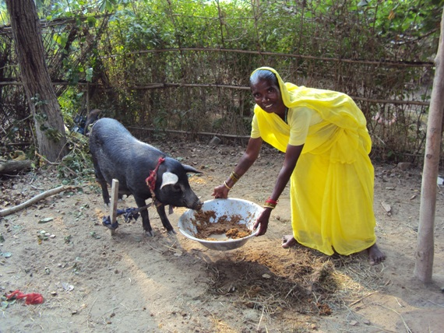
lbgx' jgL u/]/ vfg] / cfkm' / cfkmgf] kl/jf/sf] u'hf/f rnfpgdf Ao:t aif{ $! sL h;f]lwof b]jL ;bf d';x/nfO{ jgL ug'{ / k]6 eg'{ afx]s s]xLs'/fsf] 1fg lyPg . t/ @))% df ;dfh ljsf; ky, g]kfn åf/f u7Lt wgnIdL jrt ;d'xdf cfj4 eP/ k|Too]s dlxgfsf] ? @) sf b/n] jrt ug{ yflng . xfn ;f] ;d'xdf ? @%,$)) jrt ePsf 5g\ . To; jrt ;d'x jf6 h;f]lwof b]jL n] ? ^,))) C0f lnO{ xf6 -ahf/_ nfug] lbgdf v'b/f k;n u/L xKtfsf] ? !,))) sdfpg] ul5{g\ . v'b/f k;njf6 sdfPsf] k};fn] cfkmgf] gftL gftgL nfO{ ljwfnodf k9fp l5g\ .
PS;gP8 g]kfn / ;dfh ljsf; ky åf/f ;+rlnt hLjLsf]kfh{g sfo{qmd cGtu{t wgnIdL jrt ;d'xdf ljt/0f u/]sf] jfv|f / j+u'/ h;f]lwof b]jLn] k|fKt u/]sf lyP . pQm j+u'/ kfng jf6 h;f]lwof hL n] ? @@,))) cfDbfgL u/]sf 5g . / afv|f kfng jf6 ? *,))) cfDbgL ul/ !! hgf ;b:o ePsf]] kl/jf/nfO{ xftd'v hf]g{ d2t u/]sf 5g, eG5Lg h;f]lwof b]jL .
h;f]lwof b]jLn] j+u'/nfO{ cxf/ v'jfpb} u/]sf] t:jL/
wg'iff lhNnf wg'iff uf]ljGbk'/ uflj; sf] ;'gb/k'/—$ df j:g] h;f]lwof b]jL ;bf d';x/ ;d'bfodf hGd]sL Pp6L cToGt ljkGg kl/jf/sf dlxnf ;b:o x'g . lg/If/ h;f]lwof b]jL ;bf sf] 3/df b'O{ 5f]/f / b'O{ 5f]/L, b'O{ a'xf/L, ltg gftL / b'O{ cfkm} u/L !! hgfsf k/Ljf/ 5g .
h;f]lwof b]jL ;bf clxn] cfP/ hgd'lv lzIff ;DjGwL /fd|f] cg'ej kfO{ ;s]sL l5g . ljleGg tflnd, a}7s, uf]i7L, sfo{qmd, gf/fh'n';df ;xeflu x'g] ub{5Lg . ufpFsf AolQmx? nufot ltgsf d';x/ ;d'bfodf g} cu'jfsf] ?kdf lrlgg] h;f]lwof ufpF tyf cfkmgf hftsf] dm} dmu8f tyf s'g} ;d:ofx? ;dfwfg ug]{ ub{5g . cfk'm u/Lj eP/ klg 5f]/f 5f]/LnfO{ k9fP/ ljb]z hfg k};f hDdf u/L 5f]/fnfO{ ljb]z k7fPsf 5g . / cfkmgf clwsf/x? lng h'g;'s} lgsfodf ;xeflux?nfO{ nu]/ sfo{ ug{df ;Ifd ePsL l5g\ .
;+3if{n] d]/f] kfv'/f alnof] kf¥of]

jLgf dx/f wg'iff uf]ljGbk'/ & jf6 pbfPsL tf/f ag]sL l5g\ ;dfhdf . pgL g]t[Tj ug]{ dlxnffsf] ?kdf ;dfhdf :yflkt x'b}l5g\ . h;} h;} pgsf] sb prf] x'b}5 pgnfO{ r'gf}tL / vt/fx?sf] ;fdgf ug'{ kl//x]sf] 5 . t/ pgL elG5g\ ;+3if{ s/}5L t afFxL dhu't xf]O{t hfOo . cyf{t ;3if{ ub}{5' To;}n] ubf{ kfv'/f alnof] aGb} uPsf] 5 .
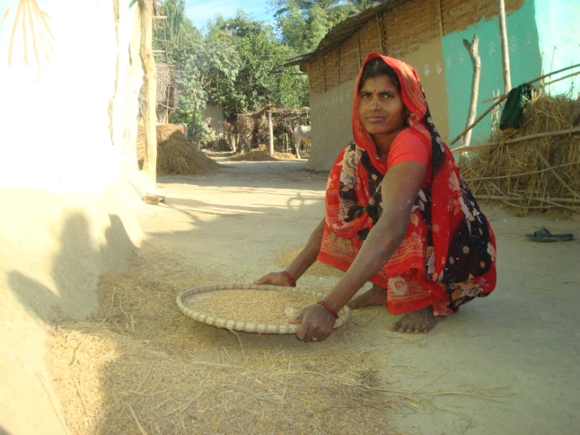
@)%@ ;fndf ljjfx eP/ o; ufpFdf cfPsL lyO{g\ . d}ynL ;F:s[lt leqsf] dlxnf lj/f]wL 3'D6f] k|yf leq pgL slhFP/ Ps bzs;Dd 3/ u/]/ vfO{g\ . t/ hgd'lv lzIff s]Gb| ufpFdf v'n] kl5 pgsf] sfof kn6 eof] . yf]/} lbgsf] 5nkmn / cEof;jf6 pgn] 3'D6f] dfq kmflngg\ s]Gb|sf] g]t[Tj klg xftdf lnO{g\ . pgnfO{ 3/jf6 klg ;xof]u ldn]g . s]Gb|df hfg] / clwsf/sf] s'/f l;s]/ ufpFdf jf]Ng yfn] kl5 ufpFsfx?n] t pgnfO{ rd}g - hflto ?kdf /fd dlxnfx?nfO{ ul/g] x]o ;+jf]wg _ g]tf eof] eGy] . 3/sfx?n] klg pgnfO{ 5f8f eO{;\ eGy] .
lj0ff elG5g\ Hofb} sl7g lyof] lt lbgx? t/ d ljrlnt eO{g\ . clxn] l:ylt km]l/of] . s;}nfO{ s]xL cK7of/f] kg{;fy pgL ;dIf cfpF5g\ lkl8tx? . lkl8tx? lk8f lnP/ cfP kl5 pgL s'g} g s'g} lgsfodf lkl8tnfO{ lnP/ k'lU5g\ . pgL w]/} k6s uflj; , k|x/L yfgf / ufpF 3/df x'g] ;fdflhs 5nkmndf uPsL l5g\ . blnt / dlxnfsL tkm{jf6 jf]n]sL l5g\ . cj t pgnfO{ j}7sx? x'g] ePdf ;+3 ;+:yf tyf sfof{nox?n] blnt dlxnf k|ltlglwsf] ?kdf lgd+q0ff u/]/ kq k7fpF5g\ . 3/sf ;f;' , b]j/ / klt klg ;sf/fTds eP .
pgn] g]t[Tj u/]/ dlxnfx?sf] Ps ;d'xnfO{ lnP/ uflj;df jh]6 dfUg uO{g\ . TofxfFjf6 d}gjlQ agfpg] / l;nfO{ s6fO{ tflndsf] nflu jh]6 k|fKt eP kl5 ;d'xsf dlxnfx?sf] klg cfTd lj:jf; a9\of] . cj pgnfO{ ;fy lbg yfn]sf 5g\ ufpFsf dlxnfx?n] . cfh pgL :yfgLo 7fpFdf Ps zlQmzfnL dlxnfsf] ?kdf pbo x'b}l5g\ . pgL elG5g\ ;+3if{n] g} d]/f] kfv'/f alnof] agfof] .

d'Vo pknAwLx?
- PS;gP8 g]kfnsf] ;xof]udf ;dfh ljsf; ky, g]kfnn] ;+rfng u/]sf] ;fd'bflos ;zlQms/0f sfo{qmd cGtu{t e'txL k6]jf{ / ;j}nf ul/ b'O{ j6f ljBfno :yfkgf u/L cg'dlt / :jLlqmtL lbnfpg ;kmn ePsf 5g\ . hDdf >L ;lxb zDe" /fli6«o k|fylds ljBfno ;j}nf—& df !^% hgf jfnjflnsfx? egf{ ePsf 5g\ . h;df blnt !$% hgf / cGodf @) hgf jfnjflnsfx? cWog ul//fv]sf 5g\ . ljBfnosf] Aoj:yfkg ;ldltdf ;ft} hgf blnt /x]sf 5g\ . h;sf] cWoIf s[ifs ;d'xsf ;lrj ljN6' dx/f ag]sf 5g\ . To:t} u/L >L dxf/fgL dfO{ /fli6«o k|fyld ljBfno e'txL k6]jf{—# df #&@ hgf jfnjflnsfx? cWog u/L /fv]sf 5g\ . h;df blnt @$( hgf / cGo !@# hgf jfnjflnsfx? 5g\ . o; ljBfnosf Aoj:yfkg ;ldltdf klg ;ft} hgf blnt /x]sf 5g\ . h;df Aoj:yfkg ;ldltdf ;ft} hgf cgk9 eP klg >L dxf/fgL dfO{ /fli6«o k|fyld ljBfnonfO{ ;+rfng ug{ ;kmn ePsf 5g\ . e'txL k6]jf{ sf jfnjflnsfx? k9gsf] nflu % lsnf] ld6/ lx8g jfWo ePsf lyP . t/ cfkmg} ufpFdf ljBfno eP kl5 cleefjsx? cfkmgf jfnjflnsfx? k9fpg ;lhnf] ePsf] jtfp5g\ . To:t} ul/ ;j}nfsf blnt ;d'bfosf jfnjflnsfx?nfO{ # lsnf] ld6/ lx8L ljBfno hfg' k/]sf] sf/0fn] k9g jf6 j+lrt ePsf lyP . t/ jxfx?sf] cfkmg} ;d'bfodf ljBfno :yfkgf ePk5L cleefjs / jfnjflnsfx?df v'lz 5fPsf] b]lvG5 .
- PS;gP8 g]kfnsf] ;xof]udf ;dfh ljsf; ky, g]kfnn] ;+rfng u/]sf] ;fd'bflos ;zlQms/0f sfo{qmd cGtu{t wg'iff lhNnf uflj; pdfk|]dk'/ a:g] xl/k'/ 3/ ePsL $ dlxnf lagf dxf;]7, rGb/ ofbj, ld7f] ;fx / dfnf ;fxn] cfˆgf] 5f]/Lsf] ljjfx ubf{ Ps ?k}of bfOhf] glbO{ ljjfx u/]sf 5g\ . oL rf/ dlxnf clwsf/ d+r, l/km\n]S6 ;]G6/, ;xsf/L ;+:yfdf cfj4 ePsL 5Lg\ . rf/} hgf eG5Lg\ xfldx?n] clwsf/sf] s'/f /fd|/L a'em]sf] / cfˆgf} ufpFdf ;dfh ljsf; ky åf/f ;+rfnLt sfo{qmodf dlxnf clwsf/ leq 3/]n' lx+;fx? / dlxnfn] kfpg' kg]{ clwsf/sf] s'/fx? k|lt al9 rf;f] /flv hflto e]befj 5'jf5't / bfOhf] k|yf ;DaGwL gfl/ lbj; sfo{qmdsf] cj;/df ! b]lv ( cf]6} j8fdf ;os8f}sf] ;+Vofdf gf/f h'n'; nufPsf lyof} . xfld dlxnfx?nfO{ ;d'bfodf k|ltsf/ ug]{ JolQmx?n] ltldx? dlxnfx? o;/L gf/fh'n'; nufpg' /fd|f] xf]Og . ltldx?n] of] s'/fsf] cGt slxn} klg ug{ ;Sb}g olb ug{ ;S5 eg] ltldx? olt df;sf] cuf9L 5f]/LnfO{ bfOhf] g lbg] / 5f]/fnfO{ bfOhf] g lng] k|lta4tf u/]/ b]vfpF . xfld h'n';df ;xeflu ePsf %)Ü dlxnfx?n] k|lta4tf hgfPsf lyP . gf/L lbj;df ;xeflu ePsf %)Ü dlxnfx?df $ hgf dlxnfn] bfOhf] glbO{ 5f]/Lsf] ljjfx ug{ ;kmn eO{ ;d'bfodf gd'gfsf] ?kdf v8f ePsf 5g\ . pgLx? ;dfh ljsf;nfO{ wGojfb lbb} eG5Lg\ cufdL lbgdf xfld $ hgf s] k'/} ufpFs} ;j}nfO} lagf bfOhf]sf] ljjfx ug{ jf4o u/fpg] k|lta4tf u/]sL l5g\ .
- l/kmn]S6 ;]G6/sf] cu'jfO{df kfFr j6} uflj;sf] #% hgf j[4f etf kmf/d e/]sf] / j[4f etf ljt/0f u/fPsf] lyof] . ;j}nf / wg'iff uf]ljGbk'/ uflj; sf] jh]6 jf6 #)—#) xhf/ /sd lnO{ d}gjtL tflnd ;+rfng u/]sf] lyof] .
- ;j}nf / e'txL k6]jf{sf] blnt j:tLdf ljBfno :yfkgf ul/ ;+rfng u/]/ ;j}nfdf !^% hgf / e"txL k6]jf{df #&@ hgf jfnjflnsfx? Kf9g df}sf kfPsf 5g\ .
- l/kmn]S6 / dlxnf clwsf/ d~r ;xeflux?sf] 5nkmnjf6 ;d'bfodf /x]sf 3/ leqsf] lx+;f ,;d:ofx?nfO s]nfO cyjf klxrfg u/L ;femf ;jfn sf] ?kdf lgzsg yfn]sf 5g\ . l/kmn]S6sf ;xeflux?sf] 5nkmnjf6 ;d'bfodf /x]sf w'D6f] k|yf ^) k|ltzt 36]sf 5g\ .
- kfFr j6} uflj;df cleefjsx?sf] ;+u7g lgdf{0f u/L ljBfno egf{ ePsf jfnjflnsfx? ljBfno jf6 Dropout x'g g lbgsf] nflu cleefjs / lzIfs ljr 5nkmn u/L ljBfno 5f8g] b/df sld cfPsf 5g\ . h;df jfnjflnsfx?sf] nflu cfPsf] 5fqj[lt ;lx?kdf ljt/0f u/fpgdf kxn u/]sf 5g\ .
- @% hgf blnt jfnjflnsfx?nfO{ ;f]8]k jf6 5fqj[lt kfPk5L plgx?sf] k7gkf7g ug{df pT;fx hfug'sf] ;fy} plgx?sf
- ljBfnodf egf{ ePsf jfnjflnsfx?nfO{ ljBfnodf l6sfpgsf] nflu, u'g:t/Lo lzIff k|bfg ug{ / åGb tyf e]befj /lxt jgfpgdf ;lqmo e"ldsf lgefPsf] h;df !^ j6} ljBfnodf 5fqj[lt ljt0f u/fpg ;kmn ePsf 5g\ .
- ;j}nfsf] >L ;lxb ;De' /f=k|f=ljBfnosf] nflu lhNnf ljsf; ;ldltsf] sfof{no jf6 $ nfv, lhNnf lzIff sfof{no jf6 @ nfv / uflj; af6 %) xhf/ sf] cg'bfg lng ;kmn ePsf 5g\ .
- ;f]]8]ksf] ;xhLs/0fdf l/kmn]S6 ;]G6/ / ;xsf/L ;+:yf sf] ;lqmotfdf e'txL k6]jf{ / ;j}nfdf k9gsf nflu # lsnf] ld6/ lxGg jf4o ePsf jfnjflnsfx?sf] nflu ToxL ;d'bfodf b'O{ j6f ljBfno :yfkgf ul/ cg'dlt / :jLlqmlt lng;kmn ePsf 5g . h;df ;f]8]k jf6 dxf/fgL dfO{ /f=k|f=lj= e'txL k6]jf{ df kmlg{r/ / aNofsaf]8{df ?= !%))) xhf/ / >L ;lxb ;De' /f=k|f=lj ;j}nfdf kmlg{r/sf] nflu ?= !),))) ;xof]u u/]sf 5g\ .
- b'j} ljBfnosf] ;+rfns ;ldlt / Aoj:yfkg ;ldltdf ;j} kbdf blntsf] ;xeflutf /x]sf] . / e'txL k6]jf{ ljBfnosf] ;+rfns ;ldlt / Aoj:yfkg ;ldltdf cgk9 eP klg @ sIff ;Dd ;+rfng ug{ ;kmn ePsf 5g\ .
- e'txL k6]jf{ df kfFr j6} ufpF ljsf; ;ldltsf & j6f sNjsf !$& hgf / >L dxf/fgL dfO{ /fli6«o k|fylds ljwfno e'txL k6]jf{sf #&@ hgf jfnjflnsfx? ldln d+l;/ % ut] @) cf}+ cGt/f{li6«o afn clwsf/ lbj; æxfdL ;a}sf] ;/f]sf/ gofF ;+ljwfgdf ;'lglZrt afn clwsf/Æ gf/fsf ;fy dgfOof] . :s'n jf6 j+lrt ePsf jfnjflnsfx? cfkmgf] ufpFdf klxnf] k6s afn clwsf/sf] nflu gf/f h'n'; u/]sf] b]v]/ v'lz x'b} ;xeflu eP/ ladnf s'df/L d+8n eG5Lg\ æo:tf] sfo{qmd d]/f] afNosfndf ePsf] eP d 3/sf] vfgf ksfpgdf dfq l;ldt geO{ cfh pgLx? h:t} eO{ c? jfnjflnsfx?nfO{ :s'n hfg k|f]t;fxg uy]{ / clwsf/sf nflu n8y] .Æ
- ;j}nfdf df kfFr j6} ufpF ljsf; ;ldltsf & j6f sNjsf !$& / >L zlxb ;De' /fli6«o k|fylds ljwfno ;j}nfsf !^% hgf jfnjflnsfx?, cleefjs, lzIfs / /fhg}lts bnsf] ;xeflutfdf lzIff lbj; dgfOof] . pQ sfo{qmddf ljBfnonfO{ e]befj /lxt / åGb /lxt /fVg] k|ltj4tf /fhg}lts bnn] u/]sf lyP .
- kfFr j6} uflj;df cleefjs, lzIfs, jfn Snj / jfn clwsf/ d+r ljr 5nkmnsf] k|efj jf6 jfn Snj / jfn clwsf/ d+r sf] cu'jfO{df kfFr j6} uflj;df ut jif{ jfnjflnsfdf vr{ ePsf] ljj/0f / cfpbf] jif{sf] sfo{ of]hgfsf] ljj/0f lr7L dfkm{t dfu u/]sf 5g\ .
- l/km\n]S6 ;]G6/sf] cu'jfO{df jfn Snj / jfn clwsf/ d+rn] lgz'Ns ?kkdf kfpg] ljtfj / 5fqj[lt ;dodf kpg' k5{ eGg] df+u ub}{ ljBfno lzIfs / ;+rfns ;ldlt ljr 5nkmn ul/ pQ jh]6 ;dodf / c:yfgLo lgsfo jf6 cfpg' k5{ eGg] c8fg u/]sf 5g\ .
- jfn k|of]hg sfo{ If]qdf jfnjflnsfx?sf] jfn kq ;+sng ubf{ ;d'bfo / 6f]n cg';f/ k|To]sdf @% hgf /flv @% j6f ;d'xdf ljefhg ul/ Ps lbgdf ! j6f ;d'xdf v]ns'b, lut / lrqsnf k|ltof]lutf u/fO{ u'g:t/Lo jfnkq ;+sng ubf{ afnaflnsfx?sf] jf}l4s ljsf;df 6]jf k'ug'sf] ;fy} /fd|f] jfnkq ;+sng eO{ ;kf]6{/nfO{ ;dodf k'u]sf] .
- k|fof]hg sfo{qmd jf/] ;fd'bflos ;jlns/0f tflndjf6 cleefjsx?n] jfn k|fof]hg sfo{qmd k|lt cfPsf] k|Zgx? sd p7g yfn]sf 5g\ / jfn kq ;+sngdf sfo{qmddf ;xeflu eO{ ;xof]u u/]sf] .
- kfFr j6} uflj;sf] k|To]s jf8{df !! hgfsf] jfn clwsf/ d+r u7g ul/ pQ d+rnfO{ uflj; :t/Lo klg u7g u/]sf] . h;df !! hgfsf] ;ldlt /x]sf 5g\ .
- kfFr j6} uflj;df k|To]s afnaflnsfx? ljBfno jf6 j+lrt x'Gg g lbgsf] nflu ljBfno egf{ cleofg cGtu{t 3/b}nf] sfo{qmdsf] dfWod jf6 cleefjsx? ;+u e]6 ul/ $@# hgf jfnjflnsfx?nfO{ ljBfno egf{ u/fPsf] . h;df dlxnf @$( hgf k'?; !&$ hgf 5g\ .
- s[ifs ;d'xsf Jolstx?n] v]tdf h}las k4lt4f/f agfPsf uf]a/dn, xl/of] dn afgP/ k|of]u ubf{ ;d'bfosf c? s[isx?n] b]vfl;lv u/]/ cfkmgf] v]tdf klg To:t} dnsf] k|of]u ug]{ k|lalwsf] pTyfg lbg lbg} a9b} uPsf] 5 .
- h}las laifflbdf ;'lt{sf] k|of]u, lgdsf] k|of]u, asfOgf], ltt]kft], l;:gf], v/flg, s[lifr'g, uf]ne]8fsf] kft, ;l/kmfsf] kft, d]jfsf] kft, uf}d'q, v';f{gL cflbsf] k|of]u ul/ h]}las laifflb tof/ kfg{ ;Sg] tyf o;sf] s'g} gsf/fTds k|efj klg gkg]{ h:tf s/fx? a'emg yfNg'sf] ;fYf} o;sf] k|of]udf klg a[l4 x'b} uPsf] 5 .
- kfFr j6} uflj;sf ;xsf/Ldf lgoldt ?kdf C0f nufgL tyf c;'nL sfo{ ug'{ sf ;fy} ;xsf/Lsf ;b:ox?n] ;xsf/L jf6 C0f lnO{ tyf cfkmgf jrt ;d]t ldnfO{ ;fgf ltgf Aoj;fo, s[lif, ljb]z hfg], s'v'/f kfng, kz'kfng,l;nfO dl;g vl/b h:tf sfo{x? ul/ hLljsf]kfh{g nfO{ ;'b[9 ul//x]]sf 5g\ .
- ;xsf/L Aoj:yfkg tflnd jf6 ;xsf/L ;+:yf Aojl:yt tl/sfn] kl/rfng ug{ tyf n]vf Aoj:yfkg ug{ ;fdflhs kl/rfns / ;xhstf{x?nfO{ ;lhnf] ePsf] .
- ;xsf/L tflnd jf6 ;b:ox?df ;xsf/L ;DjGwL 1fg j9]sf]n] ;b:otf ;+Vofdf j[l4 x'g yfn]sf] 5 .
- ;f]]8]ksf] cfof]hgfdf vfB ;'/Iff ;d'x nfO{ vfB clwsf/ ;DaGwL ;r]tgf vfB clwsf/ ,e"ld clwsf/ jf/]df ;xefuLx? a'lem oL clwsf/x? af/] ;d'bfodf ;ZfSt x'g yfn]sf] .
- plgx? cfkmgf clwsf/x? k|lt ;r]t x'b} uPsf 5g . h;n]ubf{ wg'iff uf]laGbk'/sf s[ifsx?n] lhNnf s[lif ljsf; sfof{noaf6 Kofh v]lt ug{sf] nfuL Kofhsf] lap %%Ü 5'6 b/df pknAw u/]sf 5g. Kofh v]lt ug{sf] nfuL cfjzos l;+rfO ;'lawfsf] nfuL df]6/ tyf :k|] d]l;g klg %%Ü 5'6 b/df pknAw u/fpg] ePsf 5g . ;fy} To;sf] ;fy laleGg t/sf/Lsf lap lahgx? lgzNs?kdf k|fKt u/]sf 5g .
- wg'iff uf]laGbk'/, e'TfxL k6]jf{ / ;a}nfsf ;xsf/L ;+:yfx?nfO{ ;xsf/L pkef]Stf k;n ;+rfng ug{sf] nfuL ;xsf/L l8lehg sfof{noaf6 ?= !)),))) cg'bfg k|fKt u/]sf] .
- lh=lj=;=sf] ah]6df blntsf] nflu 5'6\ofOPsf] /sd wg'iff uf]laGbk'/sf wgnIdL jrt ;d'x ;'Gb/k'/df ?= !)),))) lnPsf] h;jf6 ?= ^) xhf/sf] nfutdf ;'Gb/k'/df ;fj{hgLs bnfg lgdf{0f ug{ ;kmn ePsf] / ?= $) xhf/jf6 ;'Gb/k'/ / dvgk'/ 6f]ndf ^ j6f vfg]kfgL sn lng ;kmn ePsf] .
- ;f]8]ksf] cfof]hgfdf wg'iff uf]ljgbk'/ uflj;sf] ;'af s'6Ldf dlxnf clwsf/ d+r, ;xsf/L ;+:yf, s[ifs ;d'xsf kbflwsf/Lx? u/L hDdf #% hgf ;xeflux?nfO{ g]t[Tj ljsf; tflnd ;DkGg ePsf] lyof] . pQ tflndsf] k|lz0f ;f]8]ksf sfo{sf/L lgb]{zs ;To gf/fo0f zfx / k|fof]hg k|d'v lbk]Gb| s'df/ dxtf] n] lbg' ePsf] lyof] . tflnddf g]t[Tj eg]sf] s] xf] < ;+u7gdf o;sf] e'ldsf s:tf] x'G5 eGg] jf/]df 5nkmn ug'{ ePsf] lyof] . h;jf6 @) hgf g]t[Tj ug{ ;Sg] AolQmx? Tof/ ePsf 5g\ .
- ;f]8]ksf] ;xof]udf ;gf s[ifsx?sf] cfo cfh{g j9fpgsf] nflu % j6} uflj;sf @% j6f ;fgf s[ifsx?nfO{ a]df};dL t/sf/L pTkfbg ug{sf] nflu dn / ljp ljt/0f ubf{ To;jf6 @@ hgf s[ifsdf x/]s AolQmn] ? @),))) b]lv ? ^),))) ;Dd cfDbfgL u/L cf—cfkmgf] cfo ;|f]tdf a[l4 NofPkl5 ;d'bfosf cGo s[ifsx? b]v]/ a]df};dL t/sf/L v]tL tkm{ cfslif{t ePsf 5g\ .
- ;f]]8]ksf] cfof]hgfdf l;nfO{ s6fO{ ;DjGwL tflnd jf6 ^) hgf dlxnfx? lzk l;vL To; jf6 % hgf dlxnfn] l;nfO{ s6fO{ ul/ k|To]s dlxgfsf] ? !#)) b]lv ? !%)) ;Dd cfDbfgL u/L cfkmgf] cfo cfh{gdf j[l4 NofPsf 5g\ .
- ;f]]8]ksf] cfof]hgfdf j+u'/ kfng tflndjf6 wg'iffwfd uflj; ;;f{ 6f]nsf !) / wg'iff uf]ljgbk'/ uflj;sf ;'Gb/k'/ 6f]n jf6 !) hgf e'ldxLgn] j+u'/ kfng ;DjGwL lzk l;vL pQ kfng u/]/ ;fnsf] !% xhf/ b]lv lnP/ $) xhf/ ;Dd cfo cfh{g ug{ ;kmn ePsf 5g\ .
- kfFr j6} uflj; sf e"ldxLgx?sf] e"ldclwsf/ cleofg sfo{qmd jf6 e"ldlxgx? ;+u7Lt eO{ o; sfo{qmdn] e'dL clwsf/ k|fKtLsf]nfuL tyf PnfgL hUufdf /x]sf 3/ jf;sf] hUuf btf{ k|df0f kq kfpg cfGbf]ng ug{ tof/ ePsf 5g\ .
- e"ld cleofg sfo{qmd jf6 ;zQm eO{ @@ 3/w'/Ln] cfkmgf] gfddf hUuf btf{ u/L e"ld k|fKt ug{ ;kmn ePsf 5g\ .
- jNs hUufsf] nflu gfkL sfof{nodf bjfj lbO{ clxn] s]xL uflj;df cldg v6fO{ gfkL ug{ yfn]sf] .
- :yflgo efiffdf a'n]l6g k|sfzg ubf{ ;d'bfosf JolQmx?nfO{ a'‰g / l;Sgdf d2t k'u]sf] .
- ;d'bfo b]lv lhNnf:t/df ljleGg lgsfox?df klqsf ljt/0f eO{ sfo{If]qsf] cj:yf tyf ;+rflnt sfo{qmdx?sf] af/]df hfgsf/L u/fpg k|efjsf/L l;4 ePsf] .
- ;+:yfsf] :yflgo efiffdf æljsf;s cu|b'tÆ klqsf @))) k|lt k|sfzg ePsf] .
- ltgj6f uflj;x? wg'iff wfd, wg'iff uf]laGbk'/ / ;a}nf uf=la=;=sf ;d'xsf ;xeflux? wg'iff uf]laGbk'/sf] ;'Aaf s'l§df e]nfeO{ ;~rfng ePsf sfo{qmdx?sf] pknAwL, k|efj / ;d:ofx? af/] ;xeflud'ns ljlwåf/f 5nkmn ePsf] / Ps cfk;df l;sfO{ klg ePsf] .
- To:t} b'O6f uflj;x? e'tlx k6]jf{ / o;/L ;xeflud'ns ljl4åf/f 5nkmn ePsf]df ;xefuLx? ;sf/fTds b]lvPsf] .
- kfFrj6} uf=lj=;=sf] clwsf/jfnf, ;/f]sf/jfnf nufot ;fdflhs kl/rfns tyf ;xhstf{x? ;lxt ^) hgfsf] pkl:ytLdf ;r]tgf /}nL / vfB clwsf/ lbj; ;dkGGf ePsf] 5 . pQm sfo{qmddf Kn]sf8{ / a}g/ ;lxt clwsf/jfnfsf] ;xeflutfdf /}nL lgsfnL gu/ kl/lqmdf ul/of] . /}nL kZrft wg'iff uf]laGbk'/sf] ;'Aaf s'l§df sf]0f ;efdf kl/0ft ePsf] lyof] . dflg;sf nfuL vfB ;'/Iff d'Vo cfjZotf xf] / s'g} klg AolSt vfB clwsf/af6 alGrt x'g' x'b}g eGg] hgr]tgfdf clea[l¢ ePsf] 5 .
- vfB ;'/Ifdf ;a}sf] clwsf/ x'g'kb{5 ;fy} uf=lj=;= / /fHoaf6 k|bfg ul/Psf] x/]s ;]jf;'lawfdf ;a} ju{sf] ;dtf k'j{s kx'Fr tyf lgoGq0f x'g'kb{5 eGg] hgr]tgf tyf Ifdtf clea[l¢ ePsf] 5 .
- z'iff;gsf] nfUfL cfly{s ;fIf/tf tyf ah]6 pt/bfloTj cled'lvs/0f tflnd ;dfh lasf; kysf] ;xof]udf wg'iff uf]laGbk'/sf] ;'Aafs'l§df clawsf/jfnf, ;/f]sf/jfnf, l6d ln8/, vfB tyf e'dL clwsf/ ;jfn k|d'v, dlxnf clwsf/ ;jfn k|d'v, jfn k|fof]hg sfo{qmd k|d'v] , ;fdflhs kl/lrfns, ;xhstf{, u/L hDdf %) hgf dlxnf k'?;sf] ;xeflutf ePsf] lyof] .
- o; af6 ;d'bfosf Jolstx? k|eflat eO uf=la=;= :t/df cfpg] ;/sfl/ ah]6 /sd tyf ;/sf/af6 lbOPsf] ;]jf ;'lawf af/] hfgsf/ x'g yfn]sf 5g / cfkmgf clwsf/x? vf]Hg yfn]sf 5g .:jf:Yo rf}lsx?df cfPsf cf}iflwx? ;DaGwL hfGg a'emg yfn]sf 5g .
- kfFr j6} uflj;df ;r]tgf d'ns sfo{qmd ubf{ pglx? :jf:Yo rf}sL jf6 lgMz'Ns ?kdf k|bfg ul/Psf] cf}ifwLx? lj/fdL hfr u/fO{ lng yfn]sf 5g\ . h;df wg'iff uf]ljGbk'sf % hgf sfnfHj/ lj/fdL :jf:Yo rf}sLdf ufO{ lgMz'Ns pkrf/ u/fO{ cf}ifwL ;d]t k|fKt u/L :j:Yo ePsf 5g\ .
- To:t} pdfk|dk'/sf l6=jL= nfuL lj/fdL k/]sf nId0f lj=s=n] lgz'Ns pkrf/sf] ;fy} cf}ifwL klg lng ;kmn ePsf 5g\ .
- ;f]8]ksf] cfof]hgfdf dlxnf clwsf/ d+r / l/km\n]S6 ;]G6/sf #% hgf ;xeflun] dlxnf sfg'gL lzIff ;DjGwL tflnd k|fKt u/]/ cfkmfgf] ;d'bfodf dlxnf clwsf/sf] s'/f ug'{sf] ;fy} 3/]n' lx+;fdf k/]sf dlxnfx?sf] Gofo lbnfpgsf] nflu lhNnf ;Dd cfpg yfn]sf 5g\ .
- l/kmn]S6 ;xeflux?sf] 5nkmnjf6 ;d'bfodf /x]sf w'D6f] k|yf ^) k|ltzt 36]sf] 5 .
- lhNnf dlxnf clwsf/ d~rsf] j}7sn] !) hgf lx+;f lkl8t dlxnfx? ;d'bfod} dlxnf clwsf/ d~rdf} lgj]bg btf{ u/L Gofo kfpg ;kmn ePsf] .
- ;d'bfodf lkl8t dlxnfn] Gofo kfpg g;s]df lhNnf dlxnf clwsf/ d~rn] lhNnf k|x/L sfo{nodf % j6f s]; btf{ u/fP/ Gofo kfpg ;kmn ePsf] .
- uflj; yfgf rf}sLdf dlxnf clwsf/ d~rn] % j6f s]; btf{ u/fP/ Gofo kfpg ;kmn ePsf] .
- uflj; jh]6 lngsf nflu wgf{, jx; ,jsfnt / bjfj d"ns sfo{s|d u/L jh]6 lng ;kmn ePsf] .
- 5f} j6f uflj;df ;b:tf 7]nL ?= #))) ePsf] ;fy} dlxnfclwsf/ d~rsf] uflj;df vftf vf]Ng] k|ltj4tf hgfPsf] 5 .
- x/]s If]qdf dlxnfx?sf] %!Ü ;xeflutf ;'lglZrt x'g' k5{ eGg] jf/] cfd dlxnfx?df r]Qgfdf j[l4 ePsf] .
- lkl8t dlxnfx?nfO sfg'gL x]NknfOg ;+:yfdf lgz'=Ns s]z btf{ u/fpg ;kmn ePsf] .
- dlxnf lx+;f lj?4 /x]sf] 3/]n' lx+;f, jf]S;L k|yf, jfn ljjfx, jx'ljjfx ;DalGw hgr]Qgfdf j[l4 eO uflj; pdfk|]dk'/df kfFr hgf dlxnfn] bfOhf] glbOsg 5f]/L ljjfx ug{ ;kmn ePsf] .
- dlxnf clwsf/ d~rsf] cu'jfOdf gf/f, h'n'z /}nL wgf{n] ubf{ leqL d'6' ;Ddsf] 8/ ,qf; 36L cfTdjndf zlQm pTkGg eO cfkm} w'D6f] k|yf x6fPsf] / w'D6f] k|yfdf ^) k|ltzt sdL cfPsf] .
- !^ lbj;Lo dlxnf lx+;f lj?4 cleofgdf &%$hgf dlxnfx? ,3'D6f] gxfnL ufpF e/L Kn] sf8{ jf]sL ljleGg gf/f h'n';,–ofnL,sf ;fy gu/ kl/s|df u/L u|fld0f dlxnfx?jf6 lgsflnPsf] ;femf ;d:ofsf] ?kdf /x]sf] @$ j'Gb] dfFu kq af/] hfgsf/L lbg ;kmn ePsf] .
- o; sfo{s|ddf Pr =cfO= le= P8\;jf/] hfgsf/L u/fpbf k'?ifx?sf] ;f]rdf ;sf/fTds kl/jt{g cfPsf] 5 .
- 3'D6f] gxfnL gf/f h'n';,–ofnL u/]sf] b]v]/ kSs} klg 3'D6f] k|yfsf] cGt x'g nfu]sf] egL ?9LjfbL k'?ifx?n] rrf{ kl/rrf{ ug{ yfn]sf] .
- /fli6«o dlxnf clwsf/ d~rsf] ;fn e/Lsf] jh]6 ?= #) nfv vr{ ePsf] ljj/0f yfxf kfOof] .
- dlxnf lx+;f lkl8t x'g'sf] d'Vo sf/0f e"lddf :jfldTj gx'g' h:t}M gful/stf,ljjfx btf{ d[To' btf{ h?/L x'G5 To;t} ;+o'Qm e"lddf dlxnfsf] :jfldTj x'g' h?/L ePsf] 5 clg dlxnfsf] cl:tTj /xG5, ;+ljwfg ;ef pkfWoIf >L k"0f{f s'df/L ;'j]bL Ho"n] klg eGg' ePsf] lyof] ;fy} d o;nfO{ kfl/t g} ul/g] 5' k|ltj4tf hgfPsf] lyof] .
- ;f]8]ksf] ;xhLs/0fdf dlxnf clwsf/ d+rsf] ;lqmo ;xeflutfdf hgsk'/df gf/f h'n'; lgsfnL cGtdf sf]0f ;efdf kl/gt eO{ ;DkGg ePsf] lyof] . pQ sfo{qmddf ;+u7gsf dlxnfx?, /fhg}lts kf6L{x?, a'l4hLlj nufot ljleGg ;+3 ;+:yfx?sf] ;xeflutf lyof] .
- !^ lbj;Lo dlxnf lx+;f lj?4 cj;/ kf/L d+l;/ !@ ut] ;+ljwfg ;ef pkfWoIf >L k"0f{f s'df/L ;'j]bL ;dIf k'Ug] u/L @$ a'Fb] j8f kq lndn]zg u/L dlxnf clwsf/ d~rsf] ;xeflux?n] 1fkg kq lhNnf k|d'v clwsf/L l;l8of] dfkm{t k7fpg ;kmn ePsf] .
- d+l;/ @% ut] PSsn dlxnf ;DalGw 1fkg kq ;Ddfg0fLo k|wfg dGqL ;dIf k'Ug] u/L lhNnf k|zf;g sfof{nodf a'emfpg ;kmn ePsf] .
ef}lts tyf lgdf{0f of]hgf ;xfos dGqL snfjtL kf;dfgnfO{ @$j6f lhNnfjf6 ;+sng u/LPsf] e"lddf dlxnf / k'?if b'j}s]f ;+o'Qm gfddf nfnk"hf{ ;+ljwfgdf sfg'gL pNn]v x'g' k5{ eGg] e"lddf :jfldTj dlxnfsf] cl:tTj gf/fsf ;fy emf]nf xf:tfGt/ ul/Psf] lyof] .
l;sfO{
- h;sf] ;jfn p;}sf] cu'jfO{ / p;}sf] af]nfO x'bfv]/L ;/f]sf/ afnfx? ys{dfg x'bf] /x]5 .
- ;d'bfosf JolQmx?nfO{ ;zQm / lgw{s agfpgsf] nflu s'g} klg sfo{qmddf ;a} ;xefuLx?nfO{ clgjfo{ ?kdf s]xLgs]xL af]Ng nufpg' kb{5 .
- ;d'bfoaf6 e]befj cGt ug{sf] nflu ;d'xsf ;xeflux? af6} ;'?jft u/fpg'kbf]{ /x]5 .
- ;d'bfosf] JolQmx? cfkm} cu|;/ eO{ ;DalGwt 7fpFdf k'u]/ s'/f u/]/ ljsf; ;DalGw sfo{ dfUbf a9L k|efjsf/L x'Fbf /x]5 .
- cleofgsf] af:tljstf ;d'bfosf] JolQmx?nfO{ k|i6 hfgsf/L u/fpbf pgLx?sf] wf/0ffdf ;sf/fTds kl/jt{g eO{ ;lqmotf a9bf]/x]5 .
- ;d'bfo :jd lkl8t ePsf] ;jfnsf] af/]df s'/f x'Fbf pgLx?sf] lh1f;f a9g'sf] ;fy} PSoa4 x'bf]/x]5 .
- lhNnfdf dfq} geO{ :yflgo :t/df sfo{qmdsf] cfof]hgf x'bf a9L k|efjsf/L x'bf] /x]5 .

r'gf}tLx? / To;sf] ;fdfgf
- t/fO{ cfGbf]ng / z:q ;d'x åf/f hf/L ul/Psf] cfd x8tfnsf] sf/0fn] sfo{qmd lgwf{l/t ;dodf ;+rfng x'g g;s]sf] .
- c? ;+3 ;+:yfx?n] ;]jfd'vL cjwf/0ffdf sfd u/L /x]sf] x'bf ;d'bfosf AolQmx? ;]jfd'vL sfo{qmd k|lt j9L em'sfj x'g' .
- ufFpdf hgk|ltlgwL lalxg cj:yf cGof}nsf] /x]sf] .

lgisif{ M

clwsf/d'lv cjwf/0ffdf klg ;do ;fk]If lg/Gt/ cled'lvs/0fsf] h?/t k5{ g} . ;+:yfn] cfkm} u/]sf] cleofgjf6 l;Sg] / l;sfO{x?nfO{ ;+:yfut ug]{ Pp6f kIf xf] eg] cGo ;+:yfx?n] ljZjJofkL ?kdf s] ul//x]sf 5g\ / s'g l;sfO{nfO{ cg's/0f ug{ ;lsG5 Tof] csf]{ dxTjk'0f{ kf6f] xf] . cfhsf] ljZjdf If0fe/ d} 1fgsf] lgdf{0f x'g] / ;'rgf k|ljlwn] kne/ d} To;nfO{ ;+;f/ e/L kl:sg] sfo{ ub{5 . l;Sg rfxg]sf nflu cg's/l0fo l;sfO{x?nfO{ cfTd;ft ug{ Tolt sl7g 5}g . t/ lg/Gt/ l;Sg] / l;sfO{nfO{ ;+:yfut / x:tfGt/0f ug]{ afgL x'g'k5{ .
PS;gP8 cfkm\gf ;fem]bf/x?sf nflu Pp6f ljZj ljBfno klg xf] . :jo+ PS;gP8n] klg ;dfhdf ;}4flGts cjwf/0ffnfO{ sfof{Gjog ug]{ ;fem]bf/x?jf6 l;sl/x]sf] s'/fdf b'O{dt x'g ;Sb}g . ;f]8]kn] PS;gP8jf6 kfPsf] cled'lvs/0f cg';f/ clwsf/d'lv cjwf/0ffdf Pp6f :ki6 wf/0ffsf] ljsf; u/]sf] 5
sfo{qmdx?sf] t:jL/

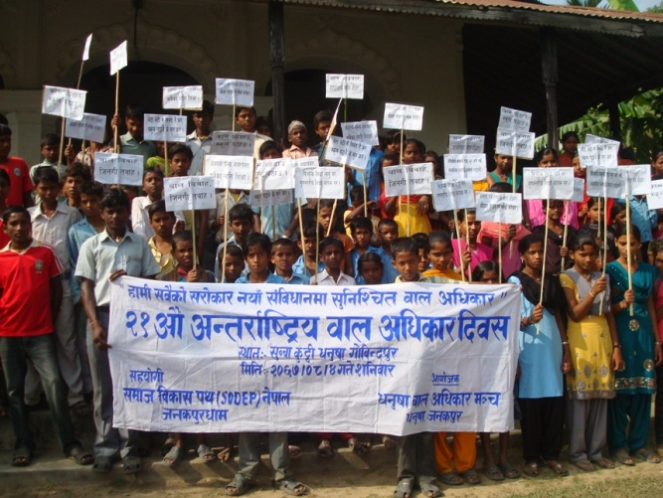
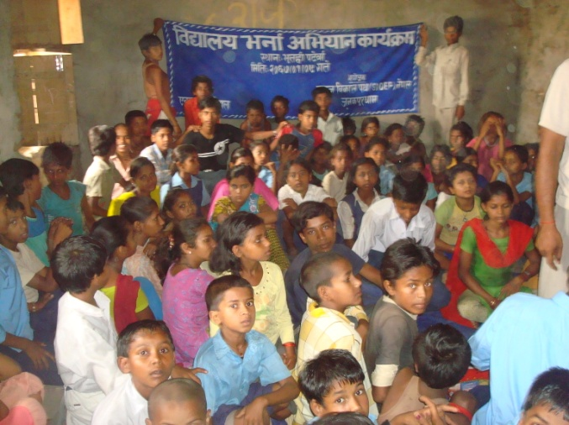
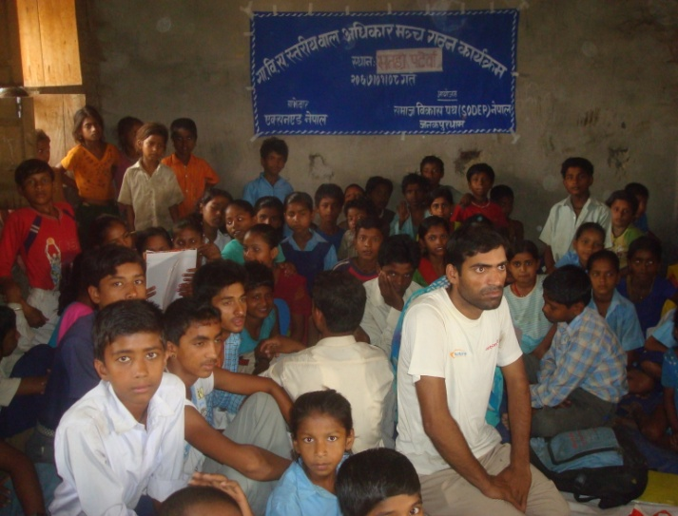
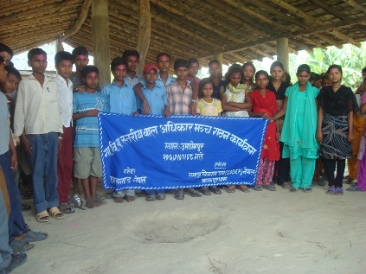
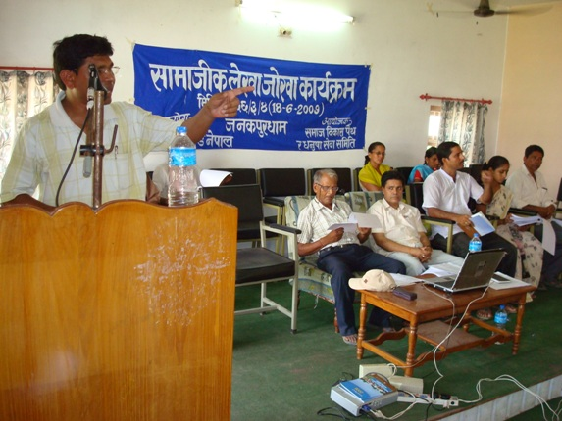
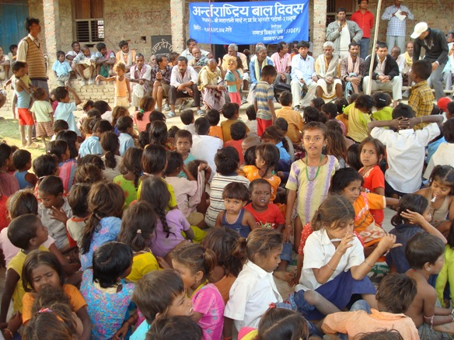
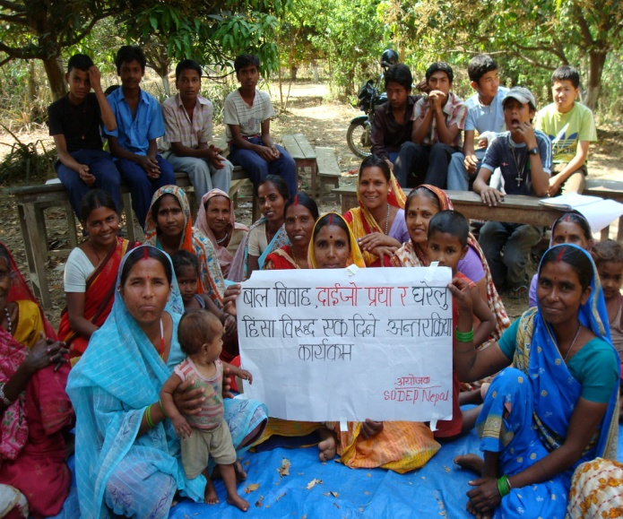
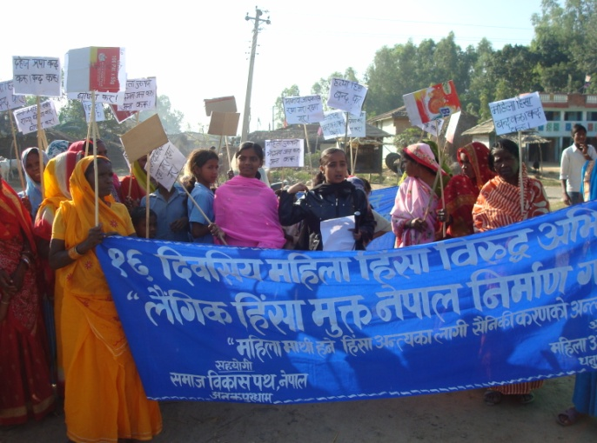
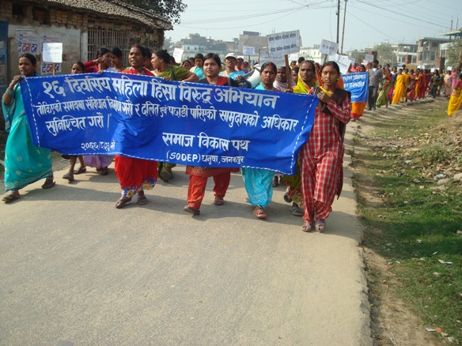
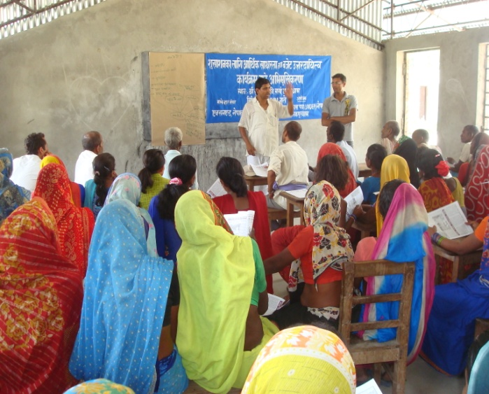
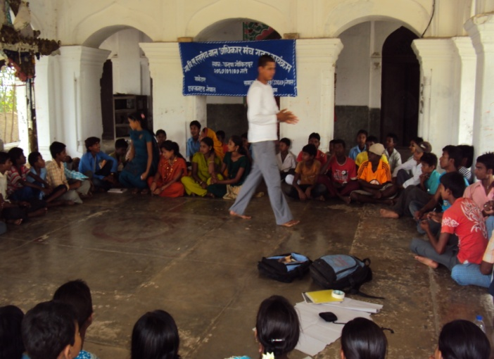
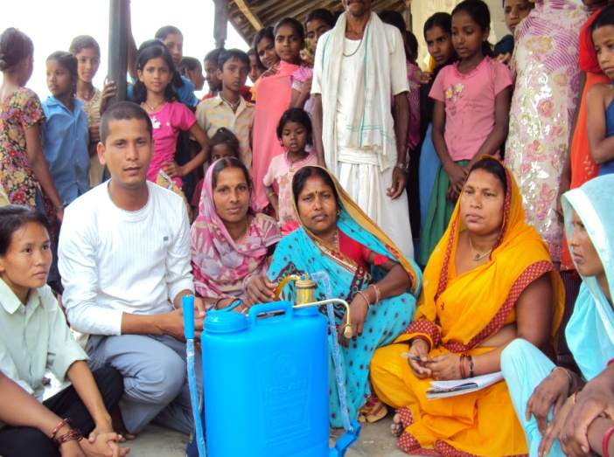
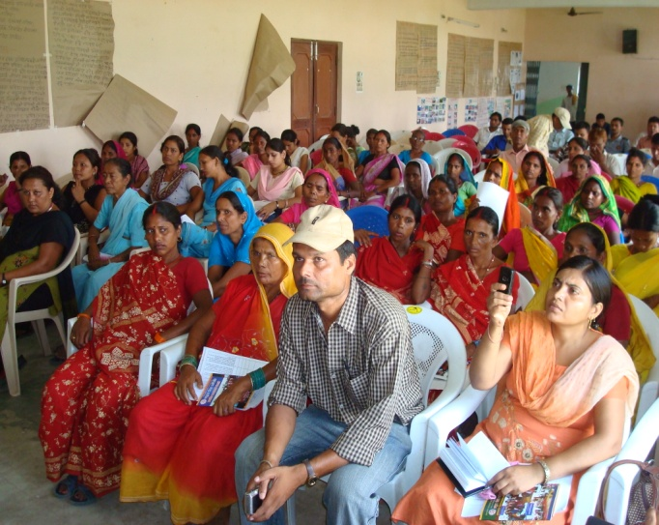
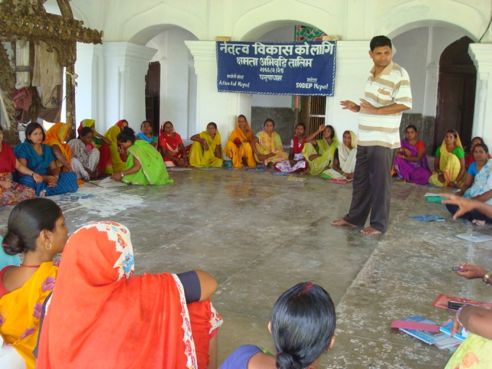
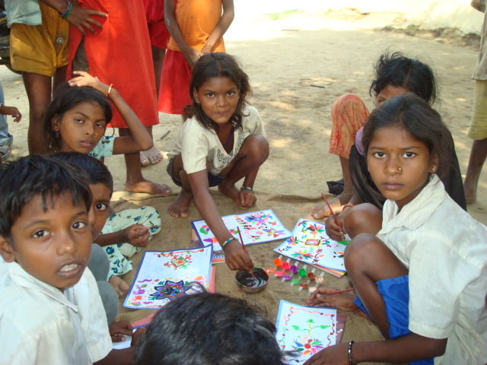
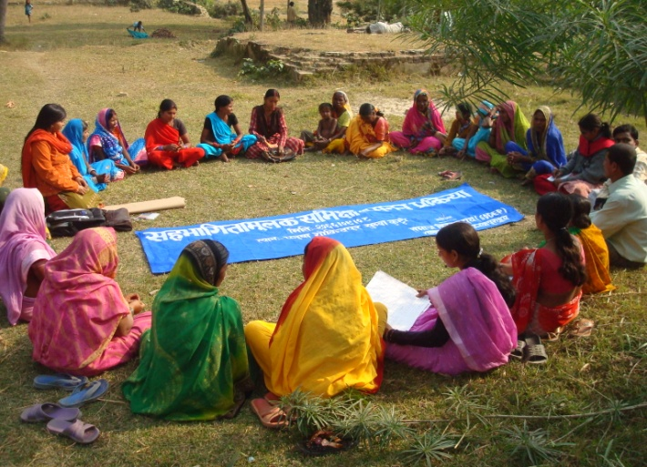
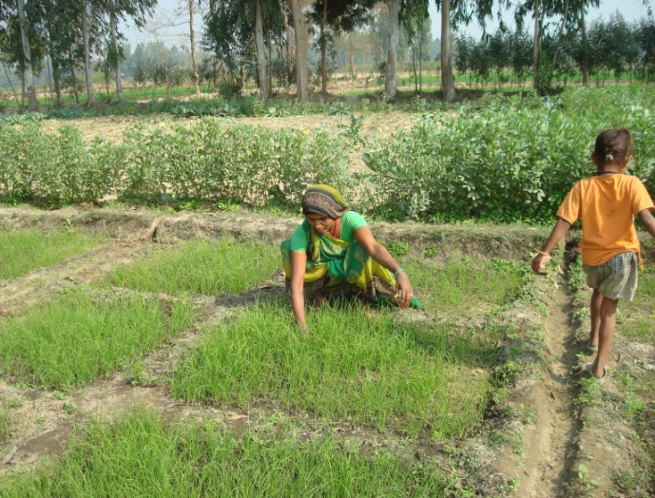
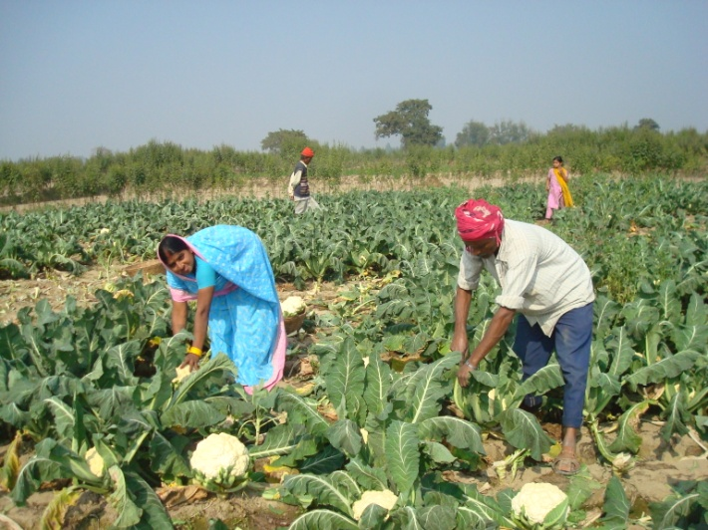

cfg cGtu{t sfo{/t sd{rf/Lsf] gdfjnL
qm=;= | gfd | kb
!= | >L lbk]Gb| s'df/ dxtf] | sfo{qmd ;+of]hs
@= | >L lbk]Gb| s'df/ l;+x | k|fof]hg ;+of]hs
#= | >L zf]ef ;fx | n]vf clws[t
$= | >L ;Ldf zfx | ;jfn k|d'v
%= | >L ;d'Gb|L s'df/L ;fx | ;jfn k|d'v
^= | >L cr{gf dxtf] | sfof{no ;xfos
&= | >L ;+ho ;fx | ;fdflhs kl/rfns
*= | >L aGbgf s0f{ | ;fdflhs kl/rfns
(= | >L hfu]Gb| ofbj | ;fdflhs kl/rfns
!)= | >L sf}l;nf yfkf | ;fdflhs kl/rfns
!!= | >L bLk]Gb| l;+x | ;fdflhs kl/rfns
!@= | dLgf ld> | ;xhstf{
!#= | lzj s'df/ dx/f | ;xhstf{
!$= | sflnsf ldemf/ | ;xhstf{
!%= | ;/Ltf d+8n | ;xhstf{
!^= | ;+hLtf s'df/L ;fx | ;xhstf{

;d'bflos ;zlQms/0f sfo{qmd
sfo{If]qM— wg'iff uf]ljGbk'/, wg'iffwfd, ;j}nf, e'txL k6]jf{ / pdfk|]dk'/
;d'x / ;d'xdf cfj4 ;+Vof ljj/0f
qm=;+ | ;d'xsf] gfd | w= uf]ljGbk'/ |  |  |  | wg'iffwfd |  |  |  | e'txL k6]jf{ |  |  |  | ;j}nf |  |  |  | pdfk|]dk'/
qm=;+ | ;d'xsf] gfd | d= | k'= | b= | h= | d= | k'= | b= | h= | d= | k'= | b= | h= | d= | k'= | b= | h= | d= | k'= | b= | h=
! | afn sNj | !# | @! | @^ | #$ | !$ | !^ | ^ | #! | & | @$ | & | #! | & | !) | !& | !& | ( | !^ | $ | @%
@ | s[ifs ;d'x | !& | ^ | ( | @# | !! | !% | & | @^ | !@ | !# | @ | @% | !# | !* | !* | #! | @^ | ^ | ! | #@
# | ;xsf/L ;+:yf | (# | — | @) | (# | $& | — | !) | $& | %^ | — | !! | %^ | %$ | — | %# | %$ | %^ | @! | # | &&
$ | dlxnf clwsf/ d+r | !^ | — | & | !^ | @% | — | * | @% | !% | — | % | !% | @# | — | @# | @# | !# | — | # | !#
% | e" c= d+r | % | * | !) | !# | & | !) | % | !& | @ | @) | !( | @@ | * | !@ | @) | @) | !) | % | * | !%
^ | l/kmn]S6 ;]G6/ -b'O{_ | $) | — | @* | $) | %% | — | #! | %% | %) | — | @! | %) | %% | — | $# | %% | $% | — | !% | $%
& | vfB ;'/Iff | !# | !% | % | @* | !) | !% | & | @% | !$ | !@ | # | @^ | ( | @) | !( | @( | !( | # | % | @@
* | j+u'/ kfng ;= | — | — | — | — | % | % | !) | !) | — | — | — | — | — | — | — | — | — | — | — | —
( | jfv|f kfng ;d'x | @! | !) | ( | #! | — | — | — | — | — | — | — | — | — | — | — | — | — | — | — | —
!) | wgnIdL jrt ;d'x | ## | — | ## | ## | — | — | — | — | — | — | — | — | — | — | — | — | — | — | — | —
!! | afn clwsf/ d+r | $* | ^! | ## | !)( | $% | ^! | !) | !)( | $$ | !)* | @# | !%@ | #( | &% | !* | !!$ | $^ | ^# | @@ | !)(
 | hDdf | @(( | !@! | !*) | $@) | @!( | !@@ | !() | #$! | @)) | !&& | (! | #&& | @)* | !#% | !(# | #$# | @@$ | !!$ | %( | ##*

